HU Extension **Assignment 11** E-63 Big Data Analytics

**Problem1**

**Download and Install neo4j**

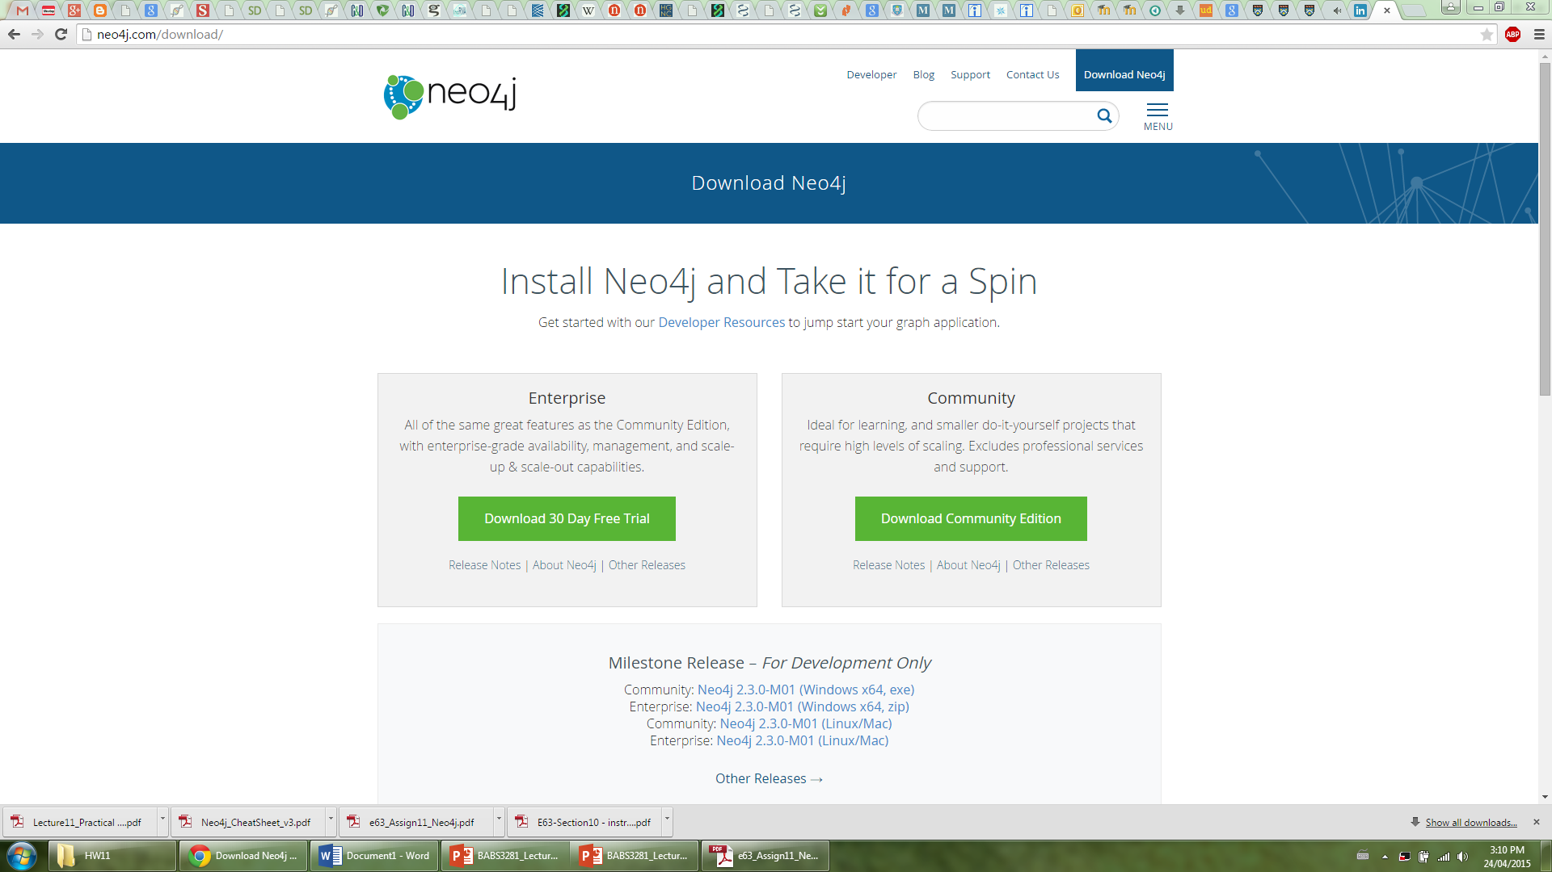

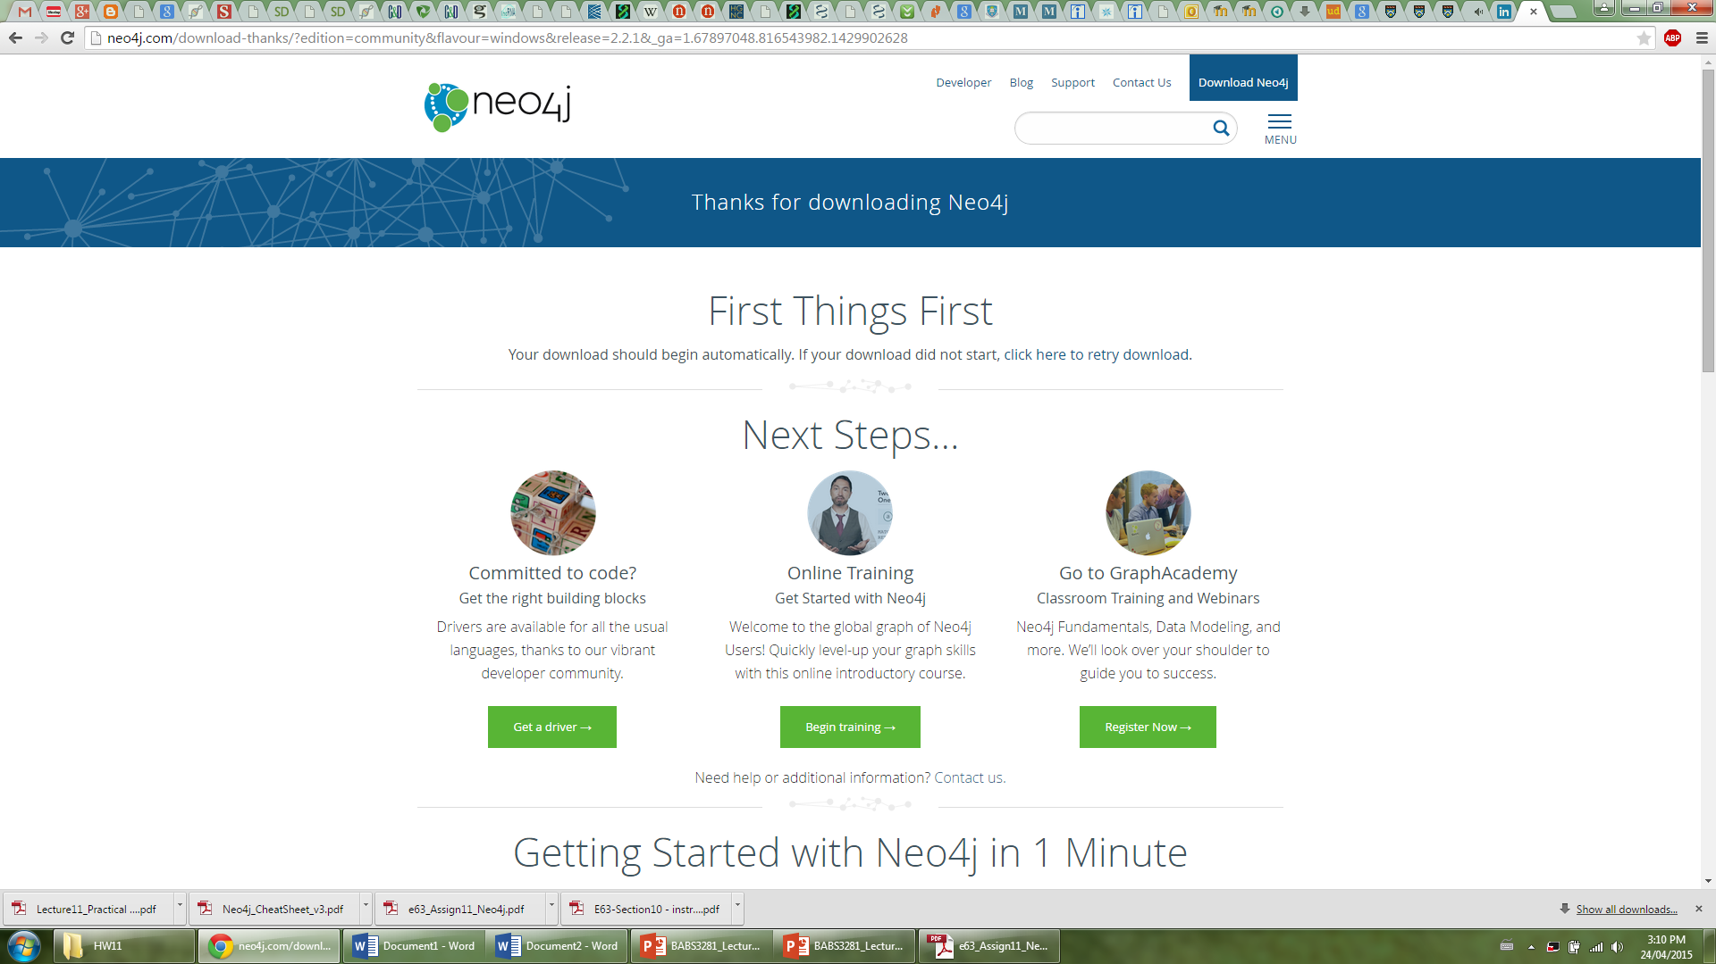

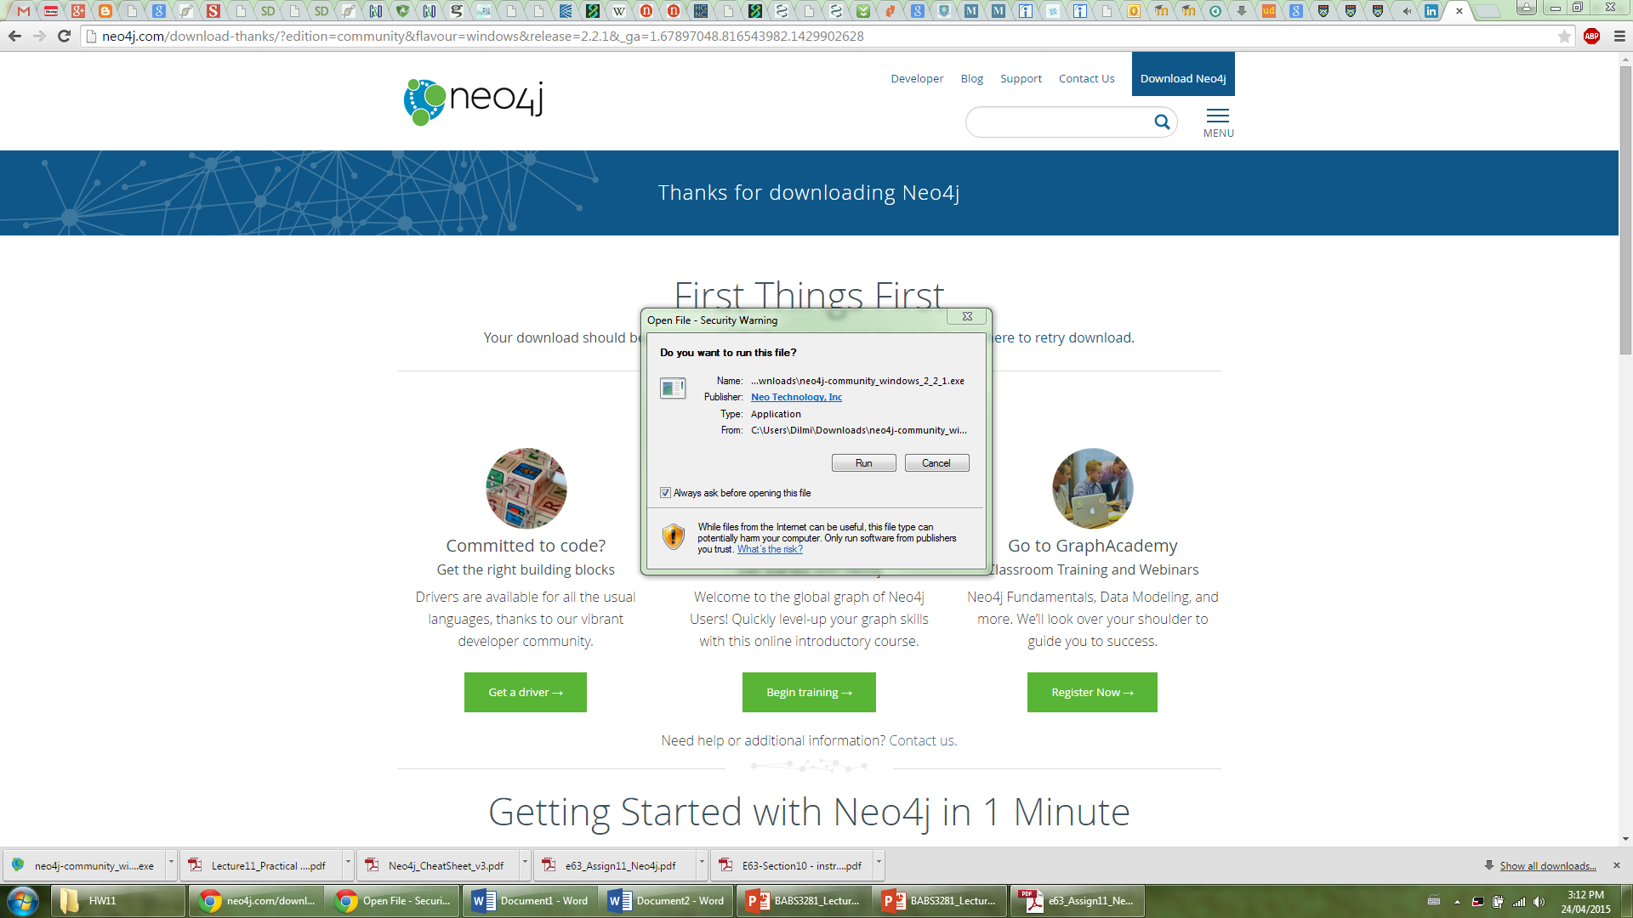

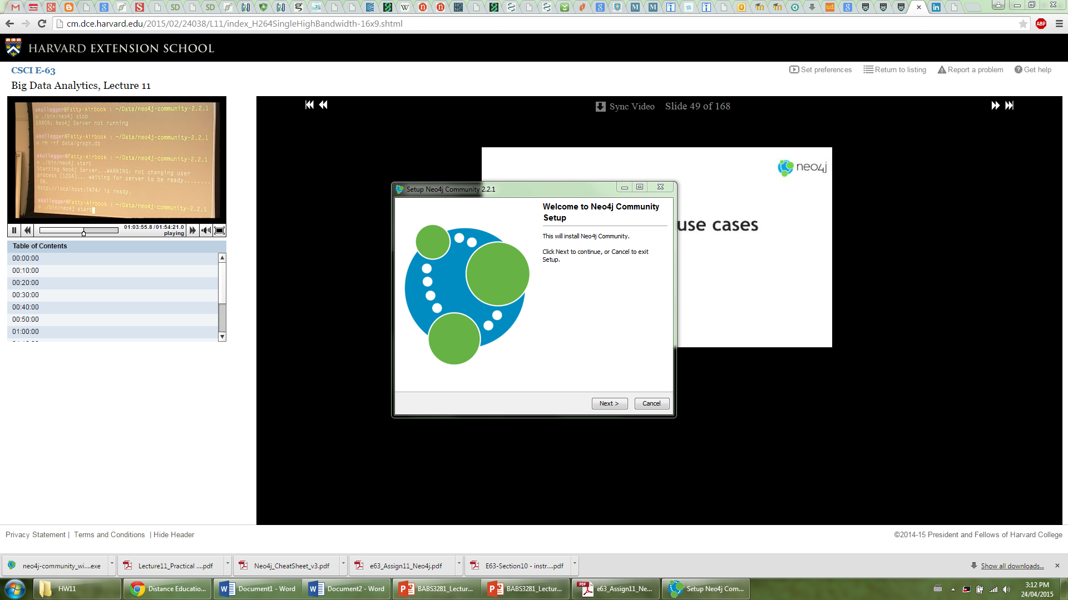

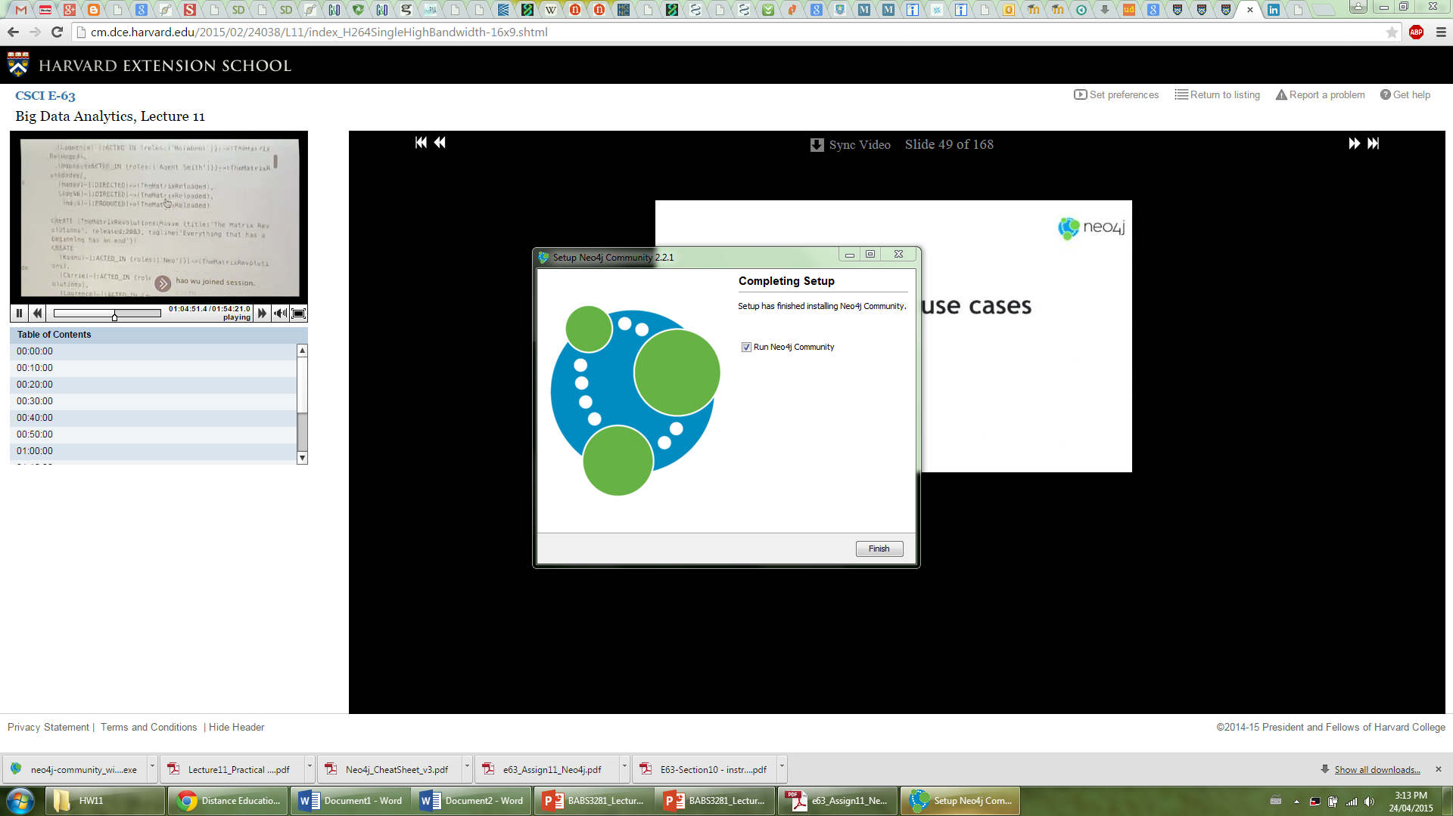

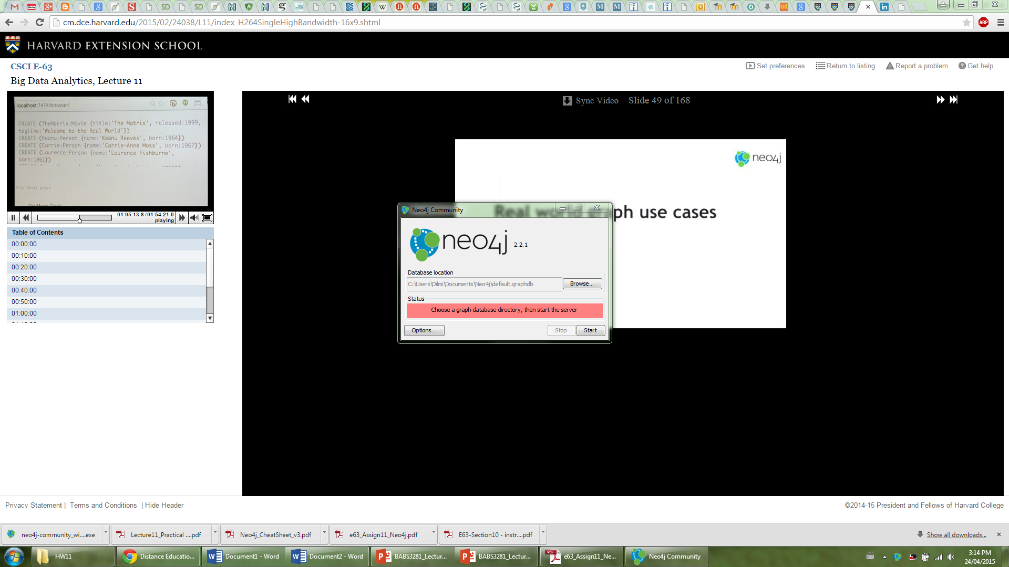

**Start neo4j**

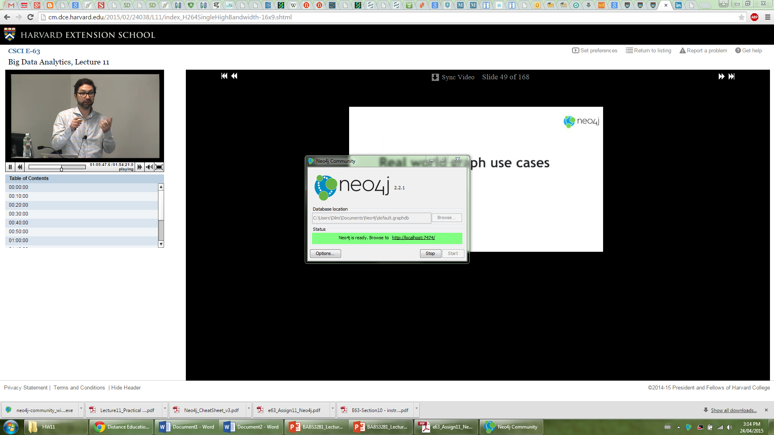

**Sign in and change default user password**

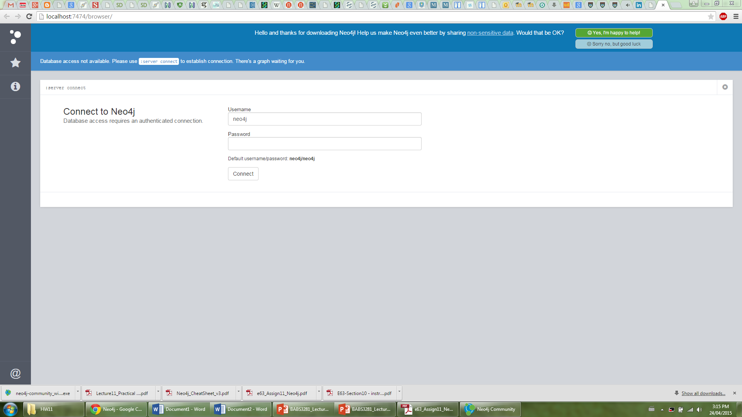

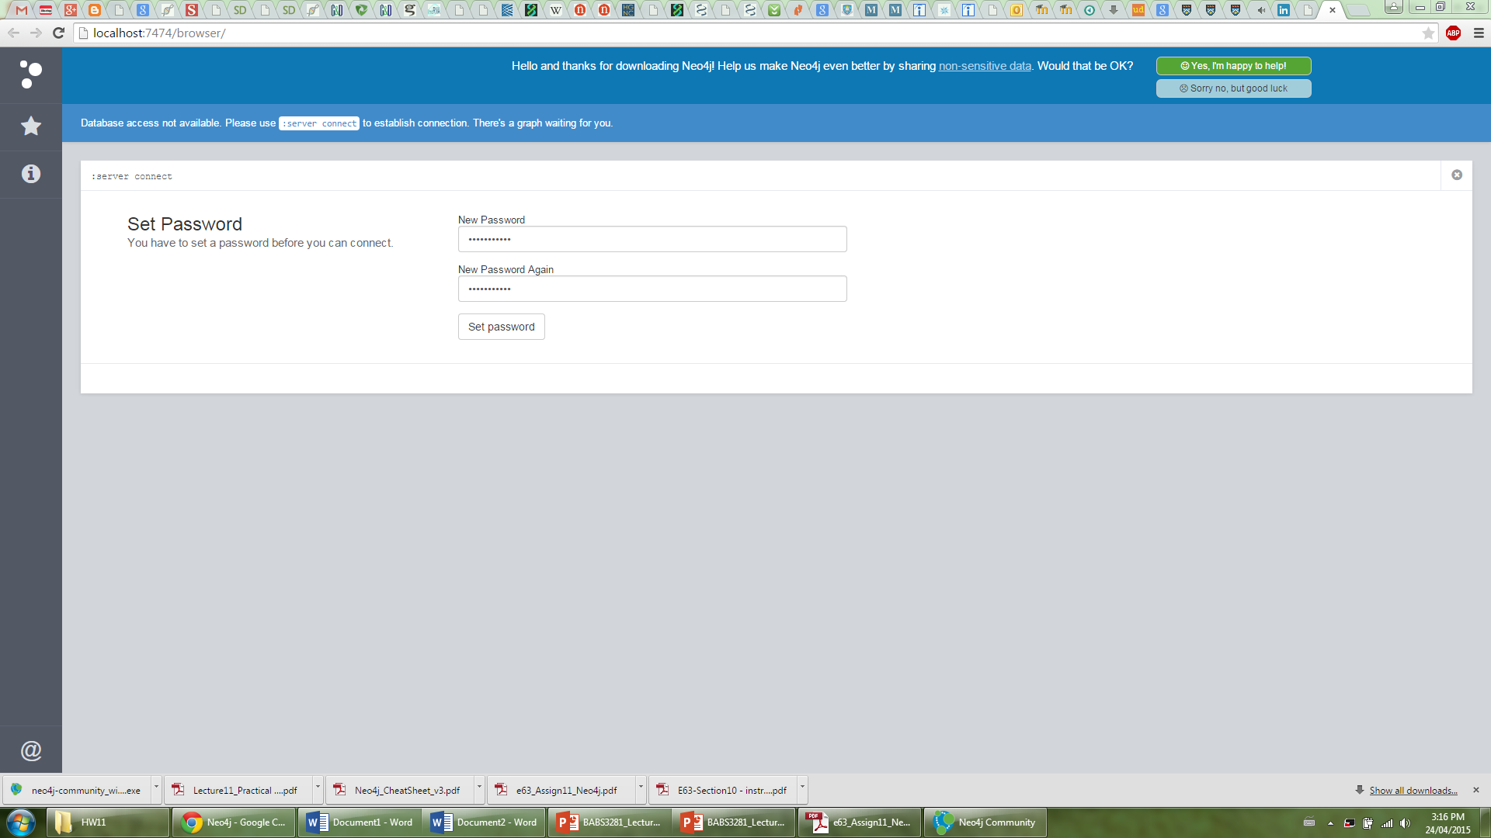

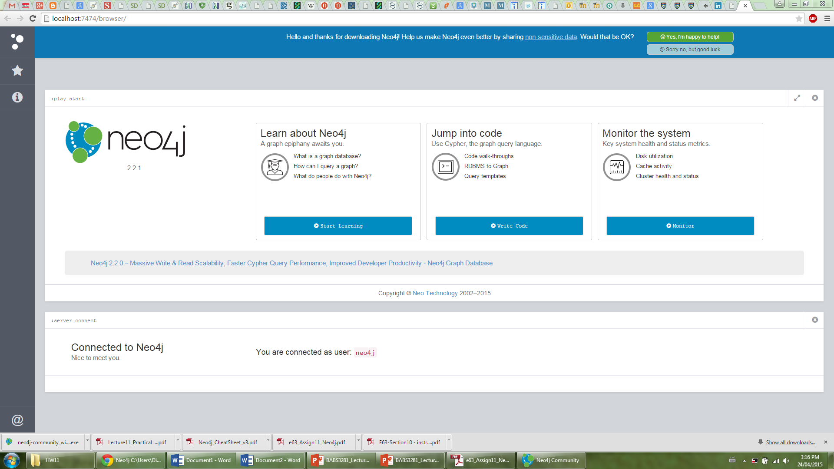

**Running the movie graph example**

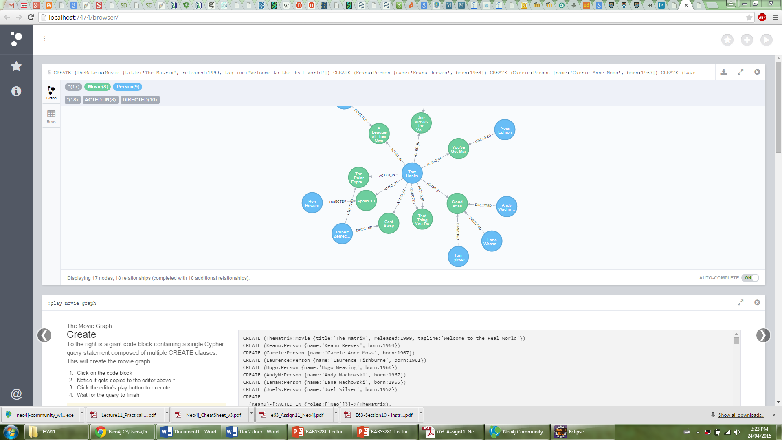

**Problem 2**

**Update Eclipse**

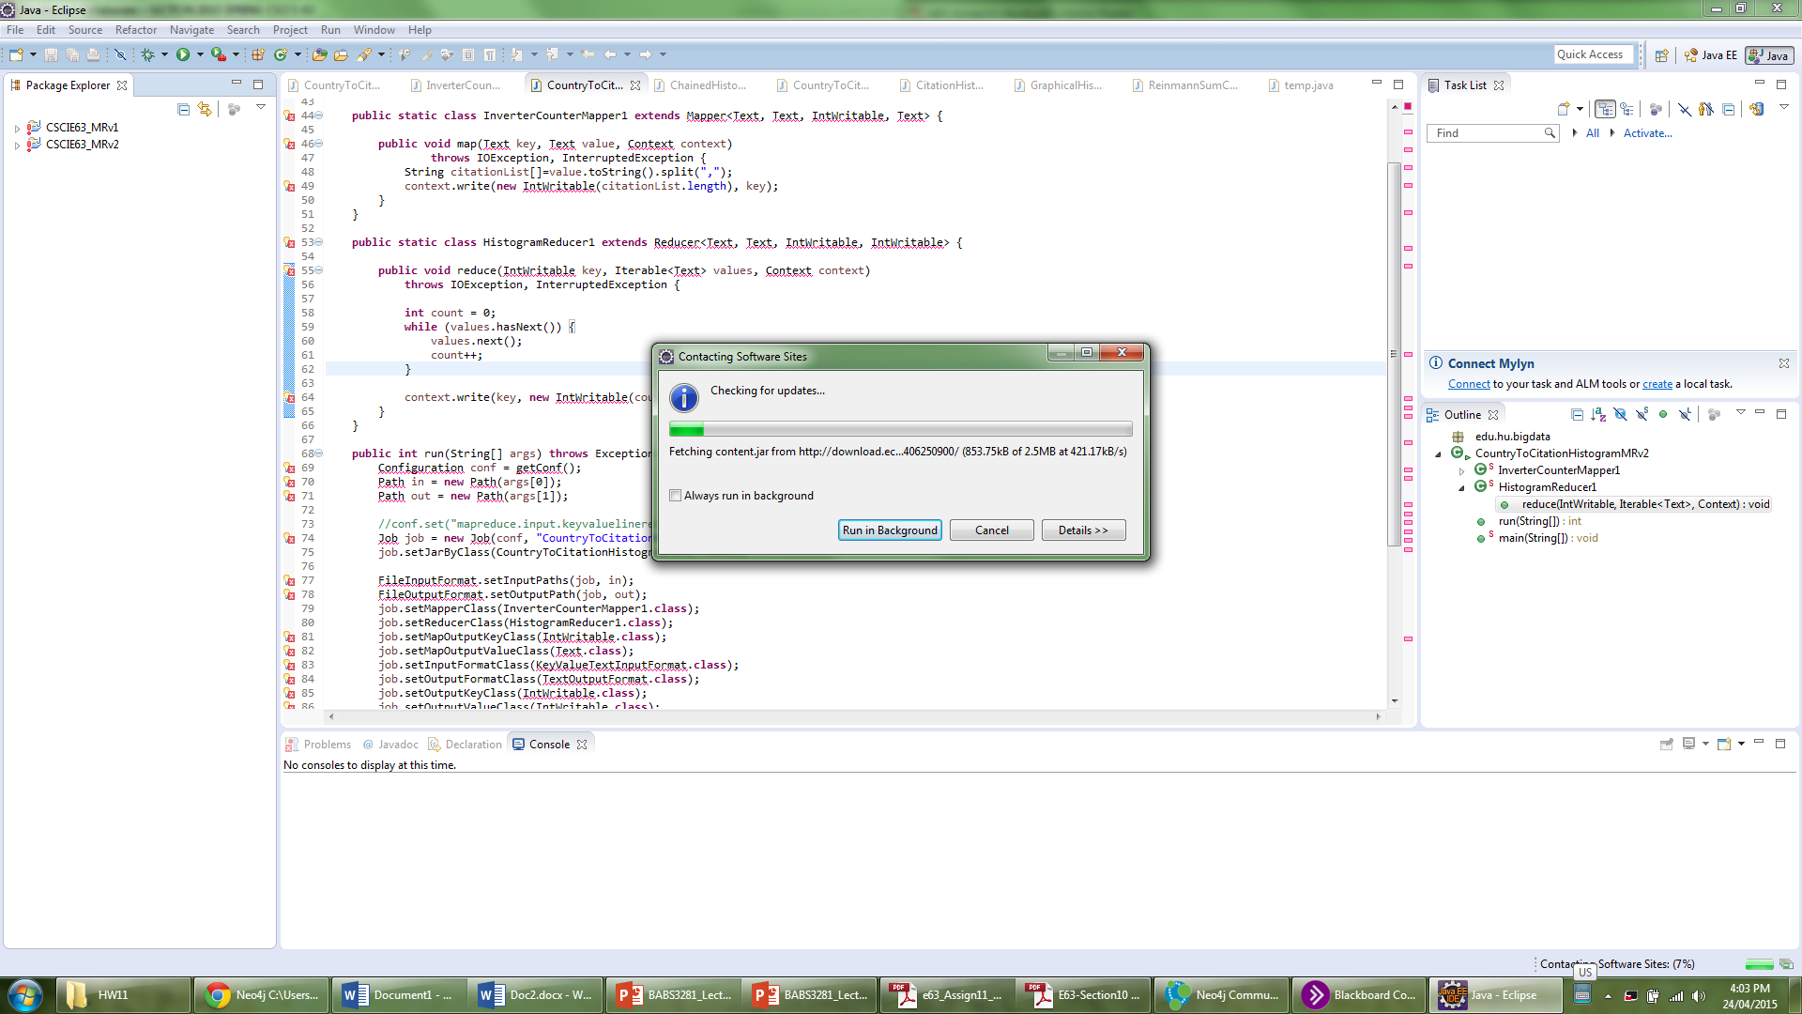

**Add m2e for Eclipse**

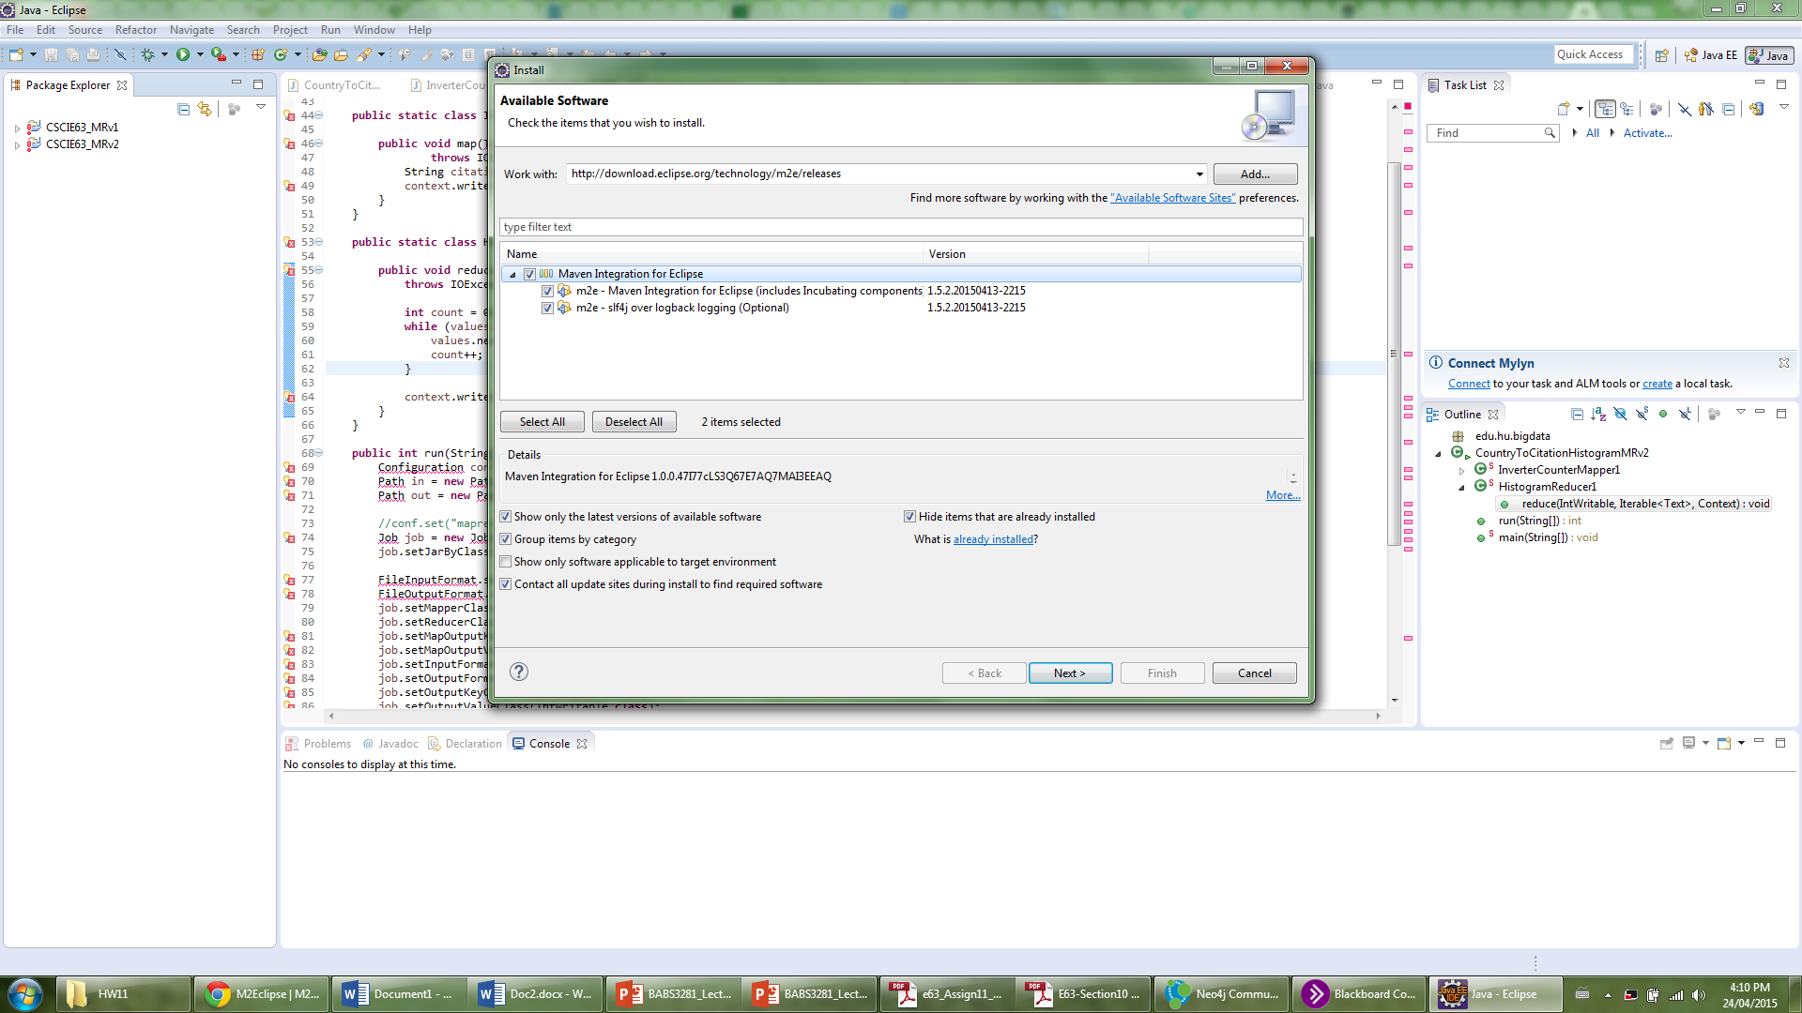

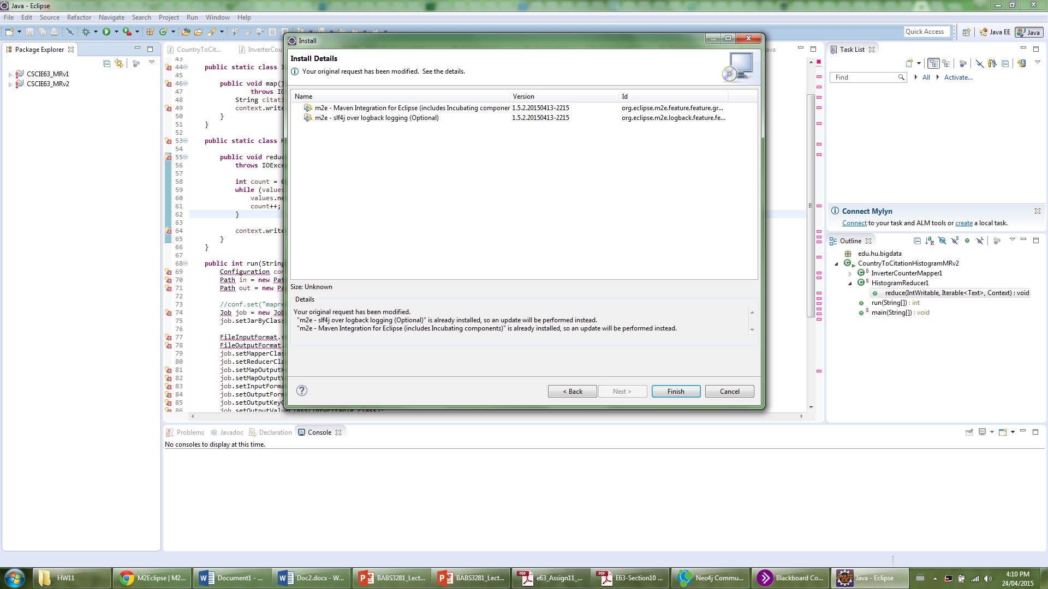

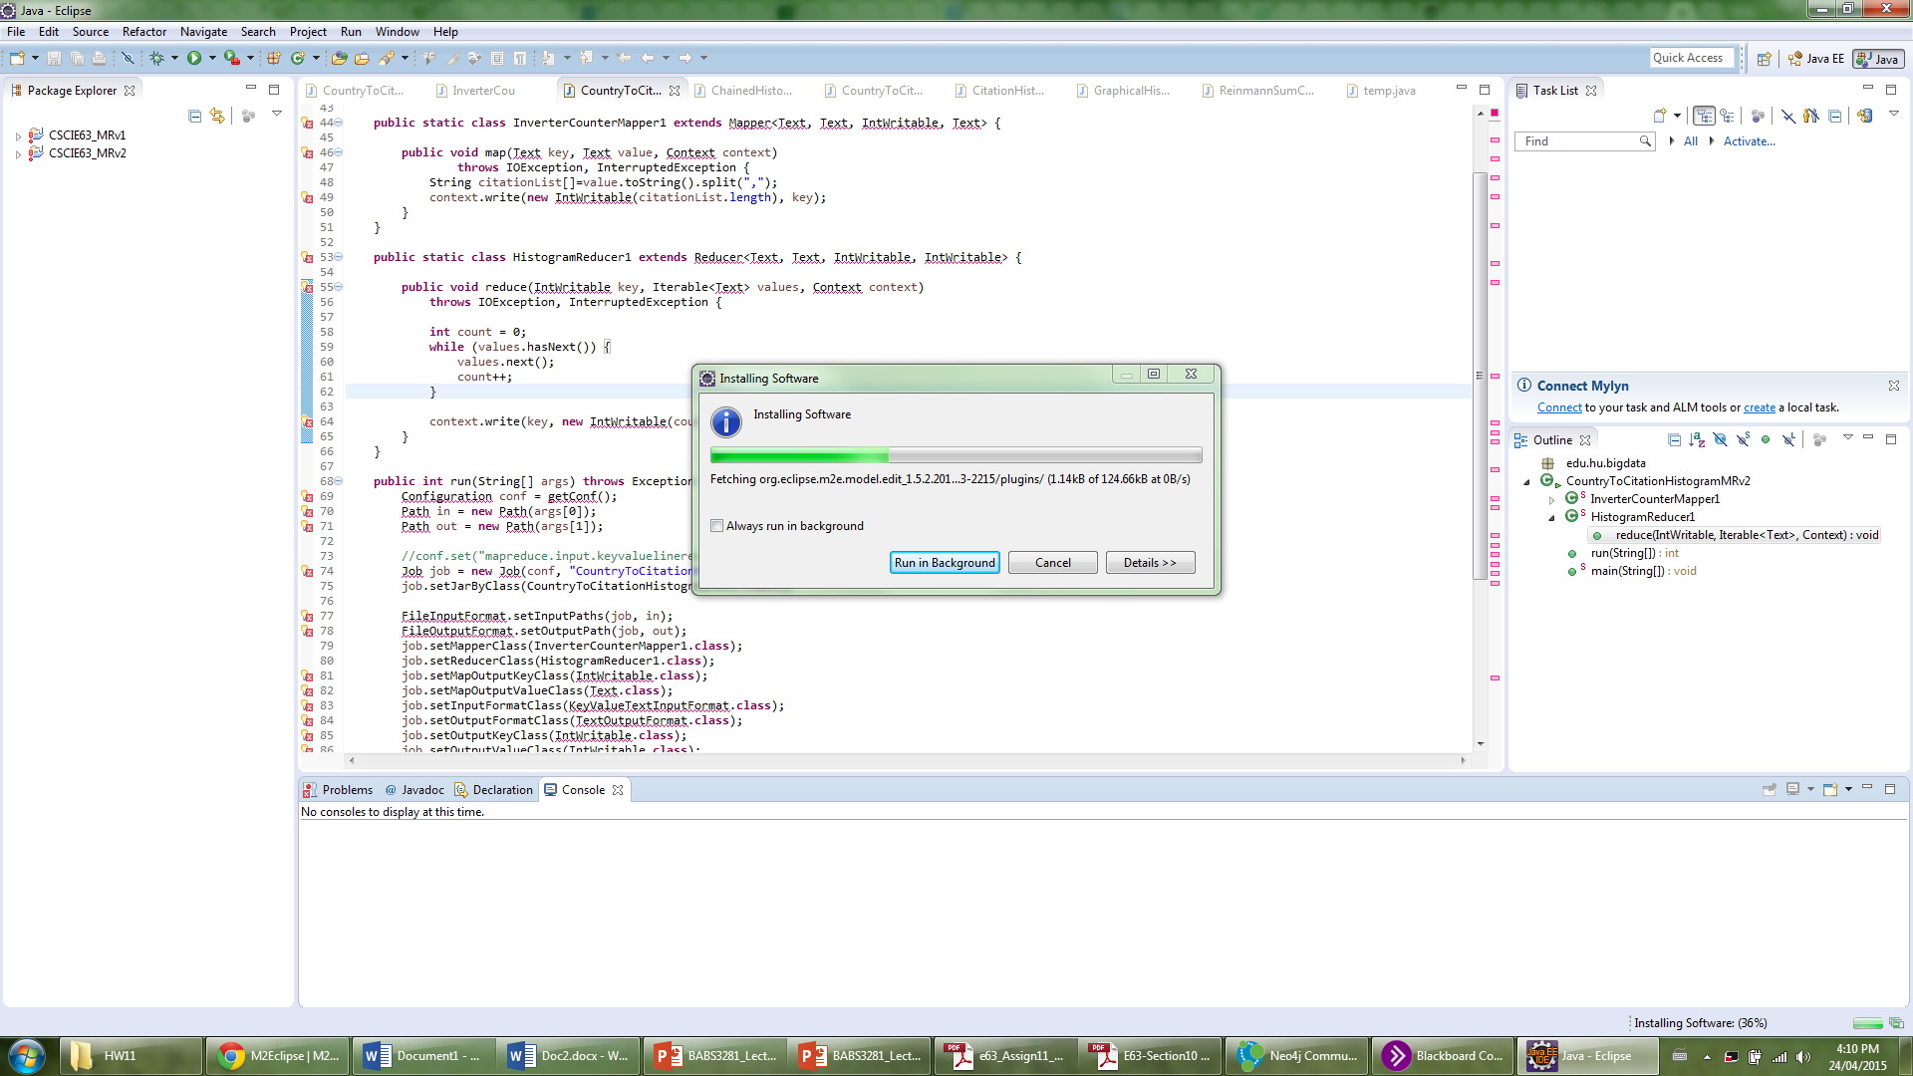

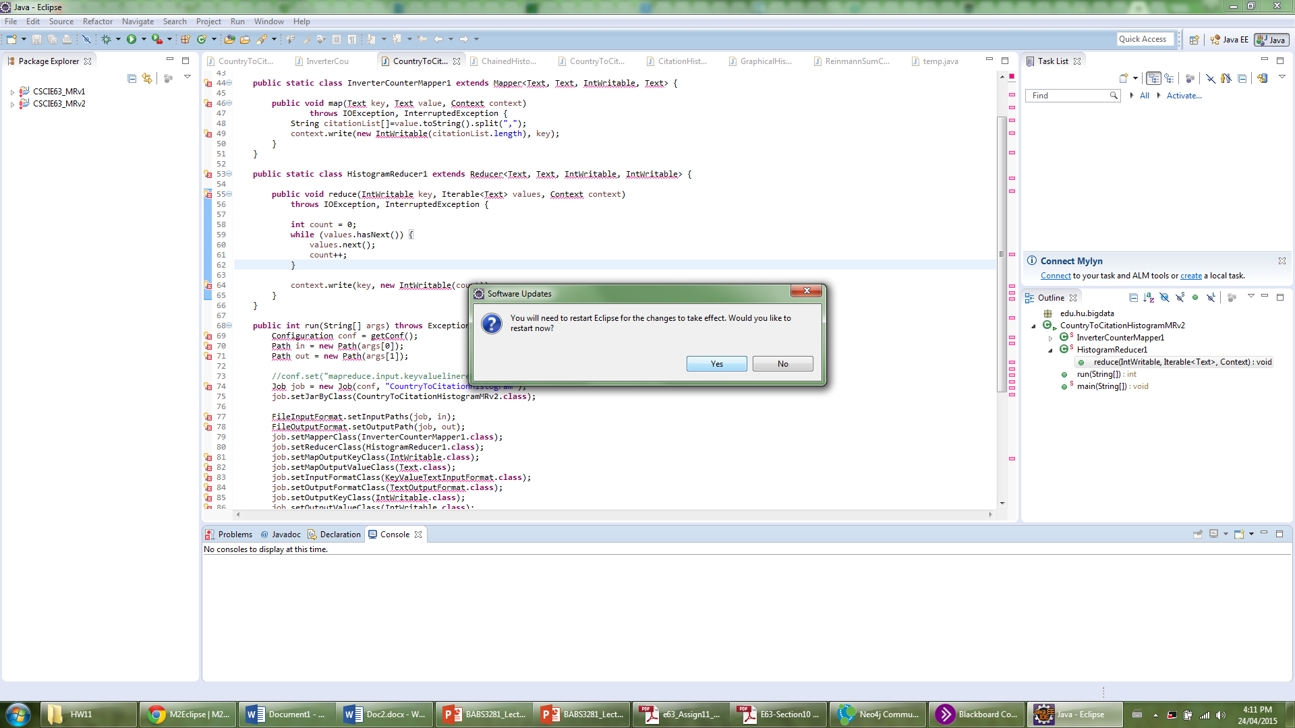

**Create new package and add java class**

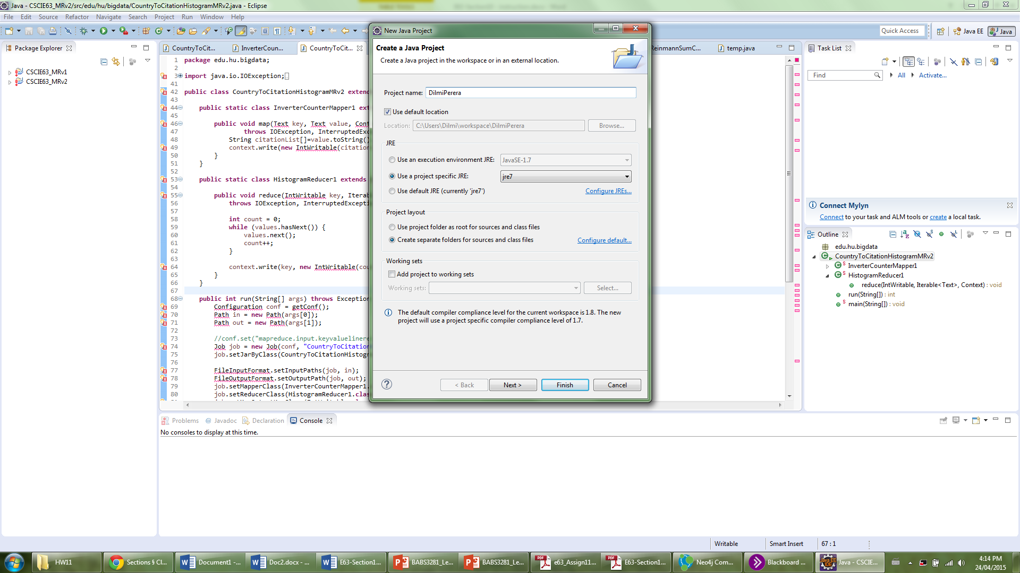

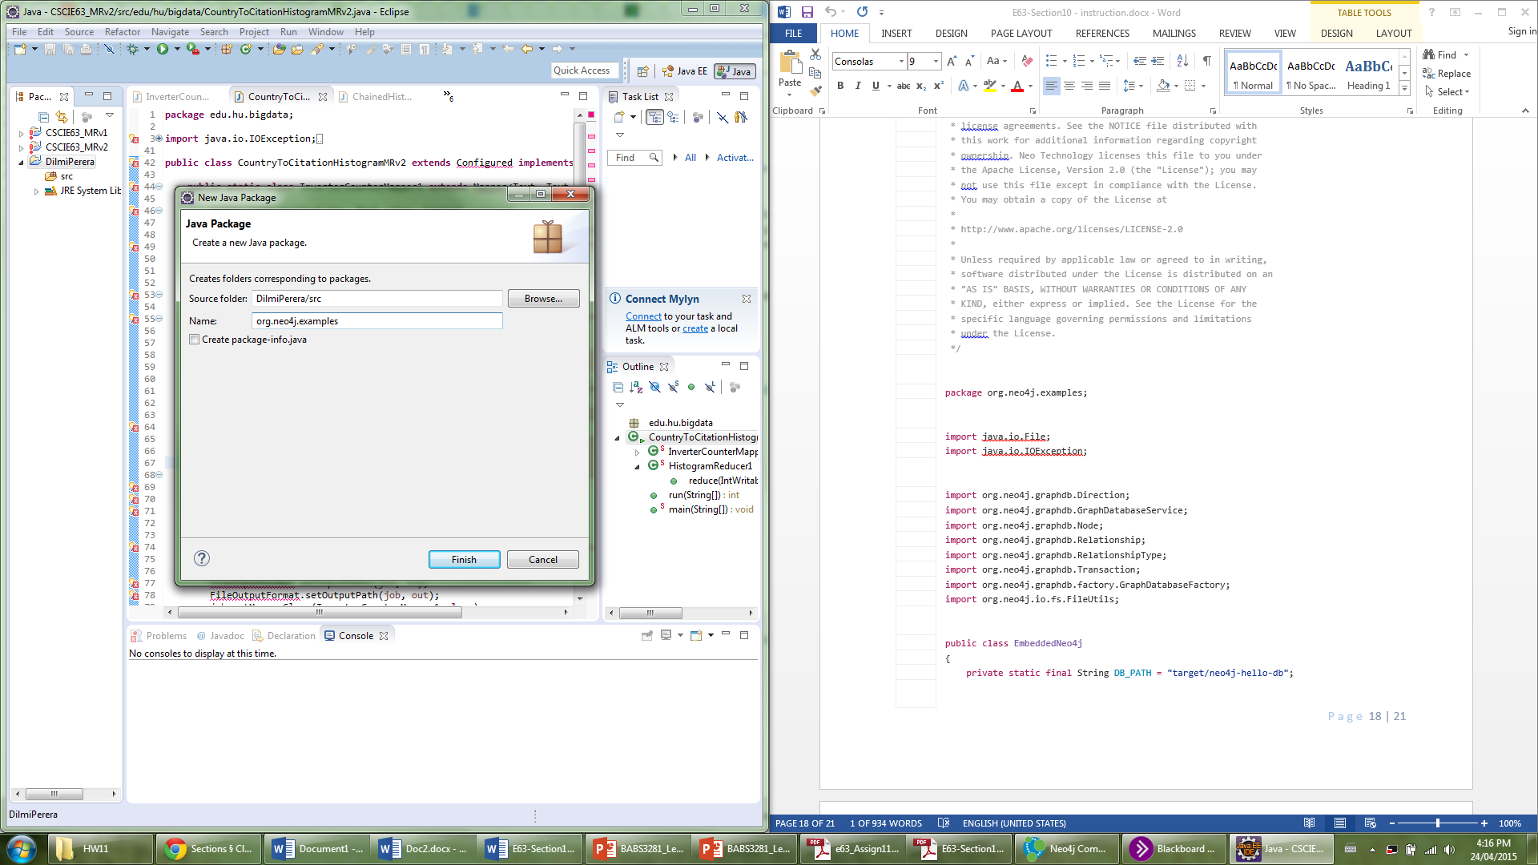

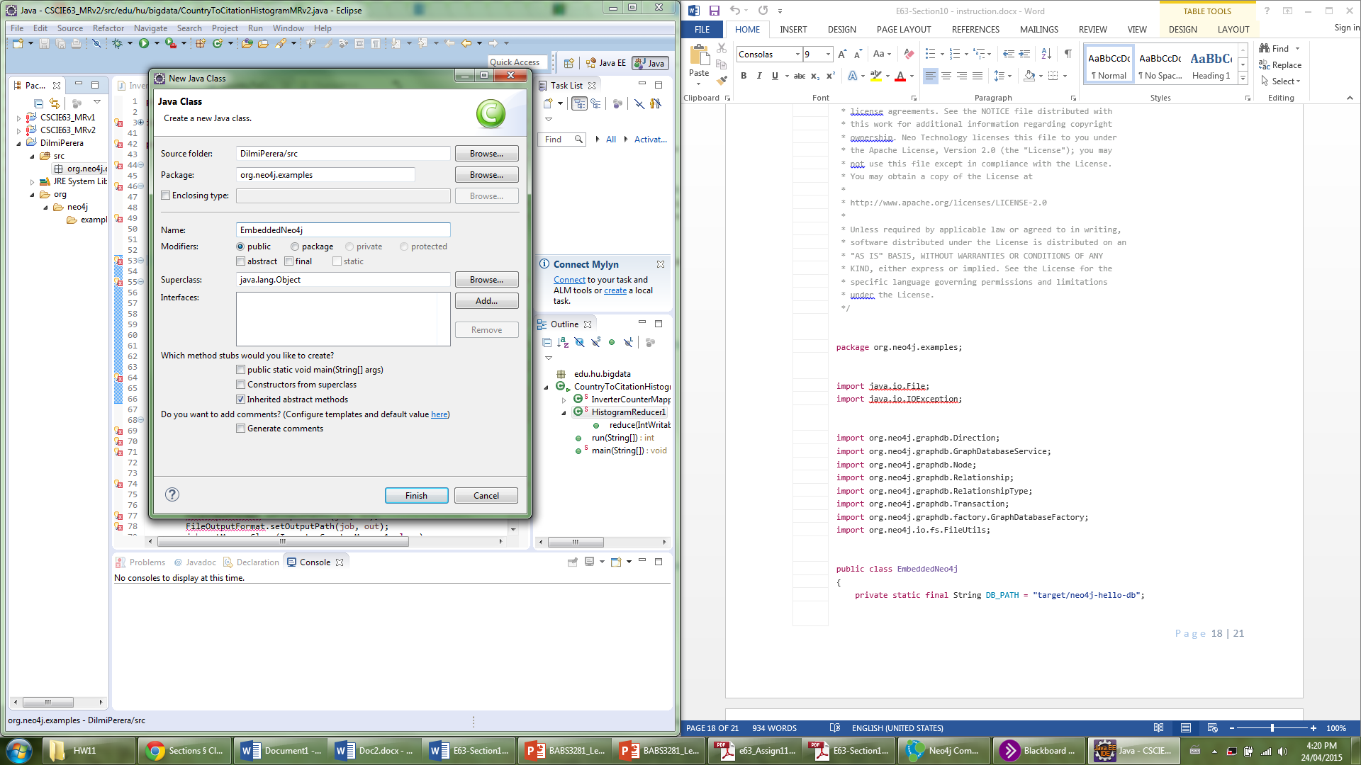

**Copy paste data from section and add libraries**

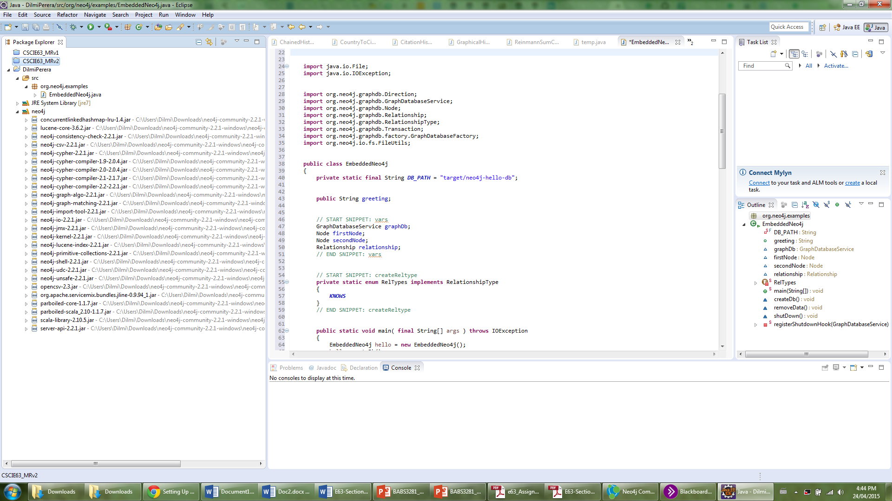

**Code description**

**Change name of database**

private static final String DB_PATH = "DilmiPerera";

**Define Nodes and Relationships**

Node firstNode;

Node secondNode;

Node thirdNode;

Node fourthNode;

Node fifthNode;

Node sixthNode;

Node seventhNode;

Node eigthNode;

Node ninthNode;

Node tenthNode;

Relationship relationship1;

Relationship relationship2;

**Define relationship types**

**private** **static** **enum** RelTypes **implements** RelationshipType

{

***CITES***

}

**private** **static** **enum** RelTypes2 **implements** RelationshipType

{

***SEQUELOF***

}

**Modify main method**

**public** **static** **void** main( **final** String[] args ) **throws** IOException

{

EmbeddedNeo4j library = **new** EmbeddedNeo4j();

library.createDb();

//library.removeData();

//library.shutDown();

}

**Initialise Nodes, relationships and set their properties**

**try** ( Transaction tx = graphDb.beginTx() )

{

// Database operations go here

// END SNIPPET: transaction

// START SNIPPET: addData

firstNode = graphDb.createNode();

firstNode.setProperty( "title", "Book1" );

firstNode.setProperty( "Author", "Author1" );

firstNode.setProperty( "year", "2001" );

secondNode = graphDb.createNode();

secondNode.setProperty( "title", "Book2" );

secondNode.setProperty( "Author", "Author2" );

secondNode.setProperty( "year", "2002" );

thirdNode = graphDb.createNode();

thirdNode.setProperty( "title", "Book3" );

thirdNode.setProperty( "Author", "Author3" );

thirdNode.setProperty( "year", "2003" );

fourthNode = graphDb.createNode();

fourthNode.setProperty( "title", "Book4" );

fourthNode.setProperty( "Author", "Author1" );

fourthNode.setProperty( "year", "2001" );

fifthNode = graphDb.createNode();

fifthNode.setProperty( "title", "Book5" );

fifthNode.setProperty( "Author", "Author1" );

fifthNode.setProperty( "year", "2005" );

sixthNode = graphDb.createNode();

sixthNode.setProperty( "title", "Book6" );

sixthNode.setProperty( "Author", "Author6" );

sixthNode.setProperty( "year", "2001" );

seventhNode = graphDb.createNode();

seventhNode.setProperty( "title", "Book7" );

seventhNode.setProperty( "Author", "Author1");

seventhNode.setProperty("year", "2007") ;

eigthNode = graphDb.createNode();

eigthNode.setProperty( "title", "Book8" );

eigthNode.setProperty( "Author", "Author8" );

eigthNode.setProperty( "year", "2008" );

ninthNode = graphDb.createNode();

ninthNode.setProperty( "title", "Book9" );

ninthNode.setProperty( "Author", "Author1" );

ninthNode.setProperty( "year", "2001" );

tenthNode = graphDb.createNode();

tenthNode.setProperty( "title", "Book10" );

tenthNode.setProperty( "Author", "Author1" );

tenthNode.setProperty( "year", "2001" );

relationship1 = firstNode.createRelationshipTo( secondNode, RelTypes.***CITES*** );

relationship1.setProperty( "type", "cites" );

relationship2 = seventhNode.createRelationshipTo( fifthNode, RelTypes2.***SEQUELOF*** );

relationship1.setProperty( "type", "sequel of" );

// END SNIPPET: addData

// START SNIPPET: readData

System.***out***.print( firstNode.getProperty( "title" )+"\t" );

System.***out***.print( relationship1.getProperty( "type" ) +"\t");

System.***out***.println( secondNode.getProperty( "title" ) );

// END SNIPPET: readData

greeting = ( (String) firstNode.getProperty("title" ) )

+ ( (String) relationship1.getProperty( "type" ) )

+ ( (String) secondNode.getProperty( "title" ) );

// START SNIPPET: readData

System.***out***.print( seventhNode.getProperty( "title" ) +"\t");

System.***out***.print( relationship2.getProperty( "type" ) +"\t");

System.***out***.print( fifthNode.getProperty( "title" ) );

// END SNIPPET: readData

greeting = ( (String) seventhNode.getProperty("title" ) )

+ ( (String) relationship2.getProperty( "type" ) )

+ ( (String) fifthNode.getProperty( "title" ) );

// START SNIPPET: transaction

tx.success();

}

**Run java file**

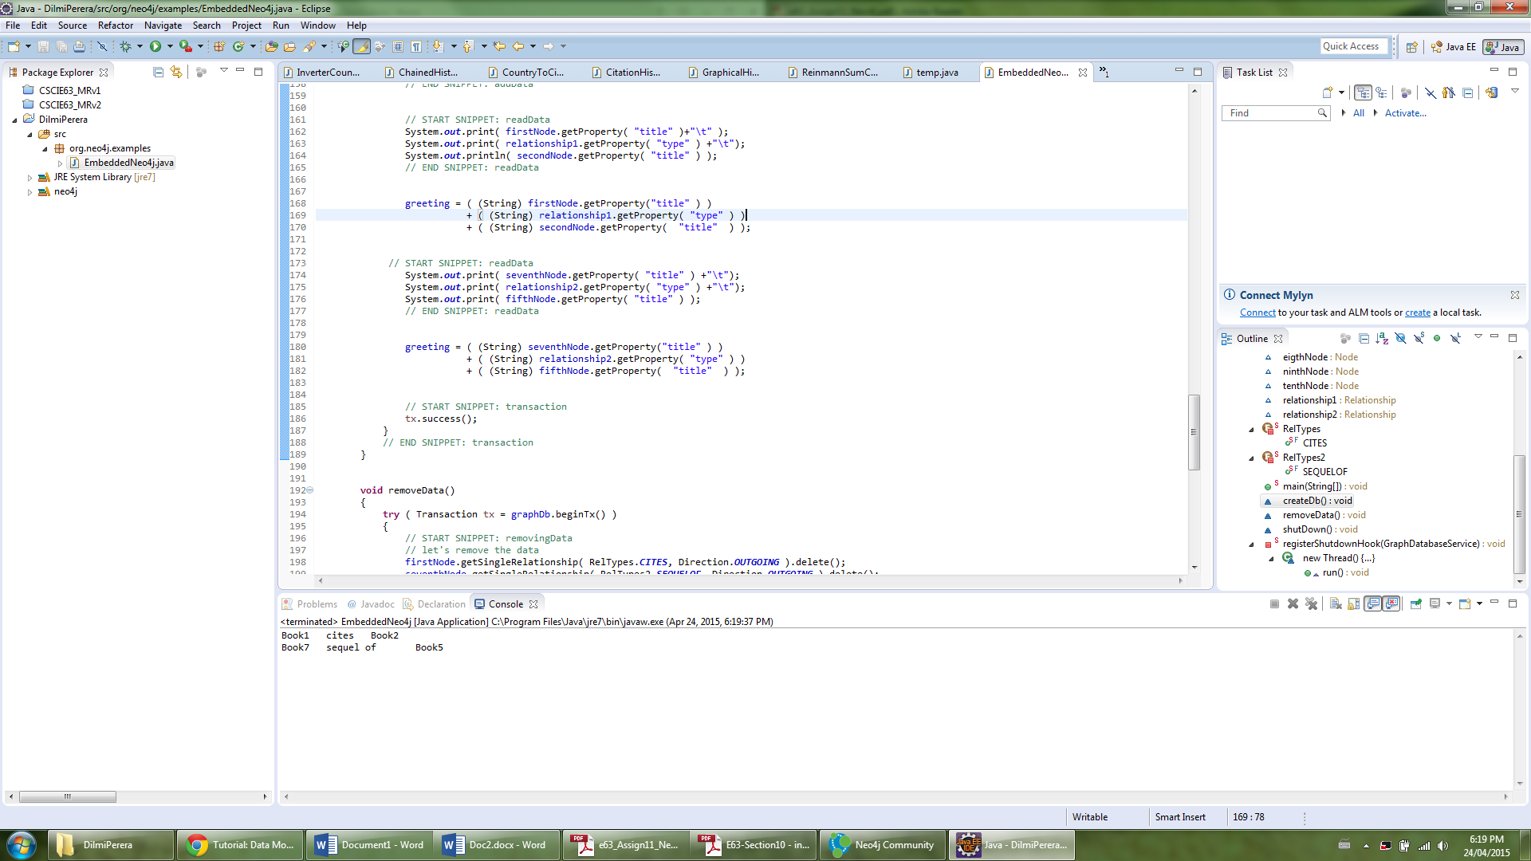

**Stop ne4j**

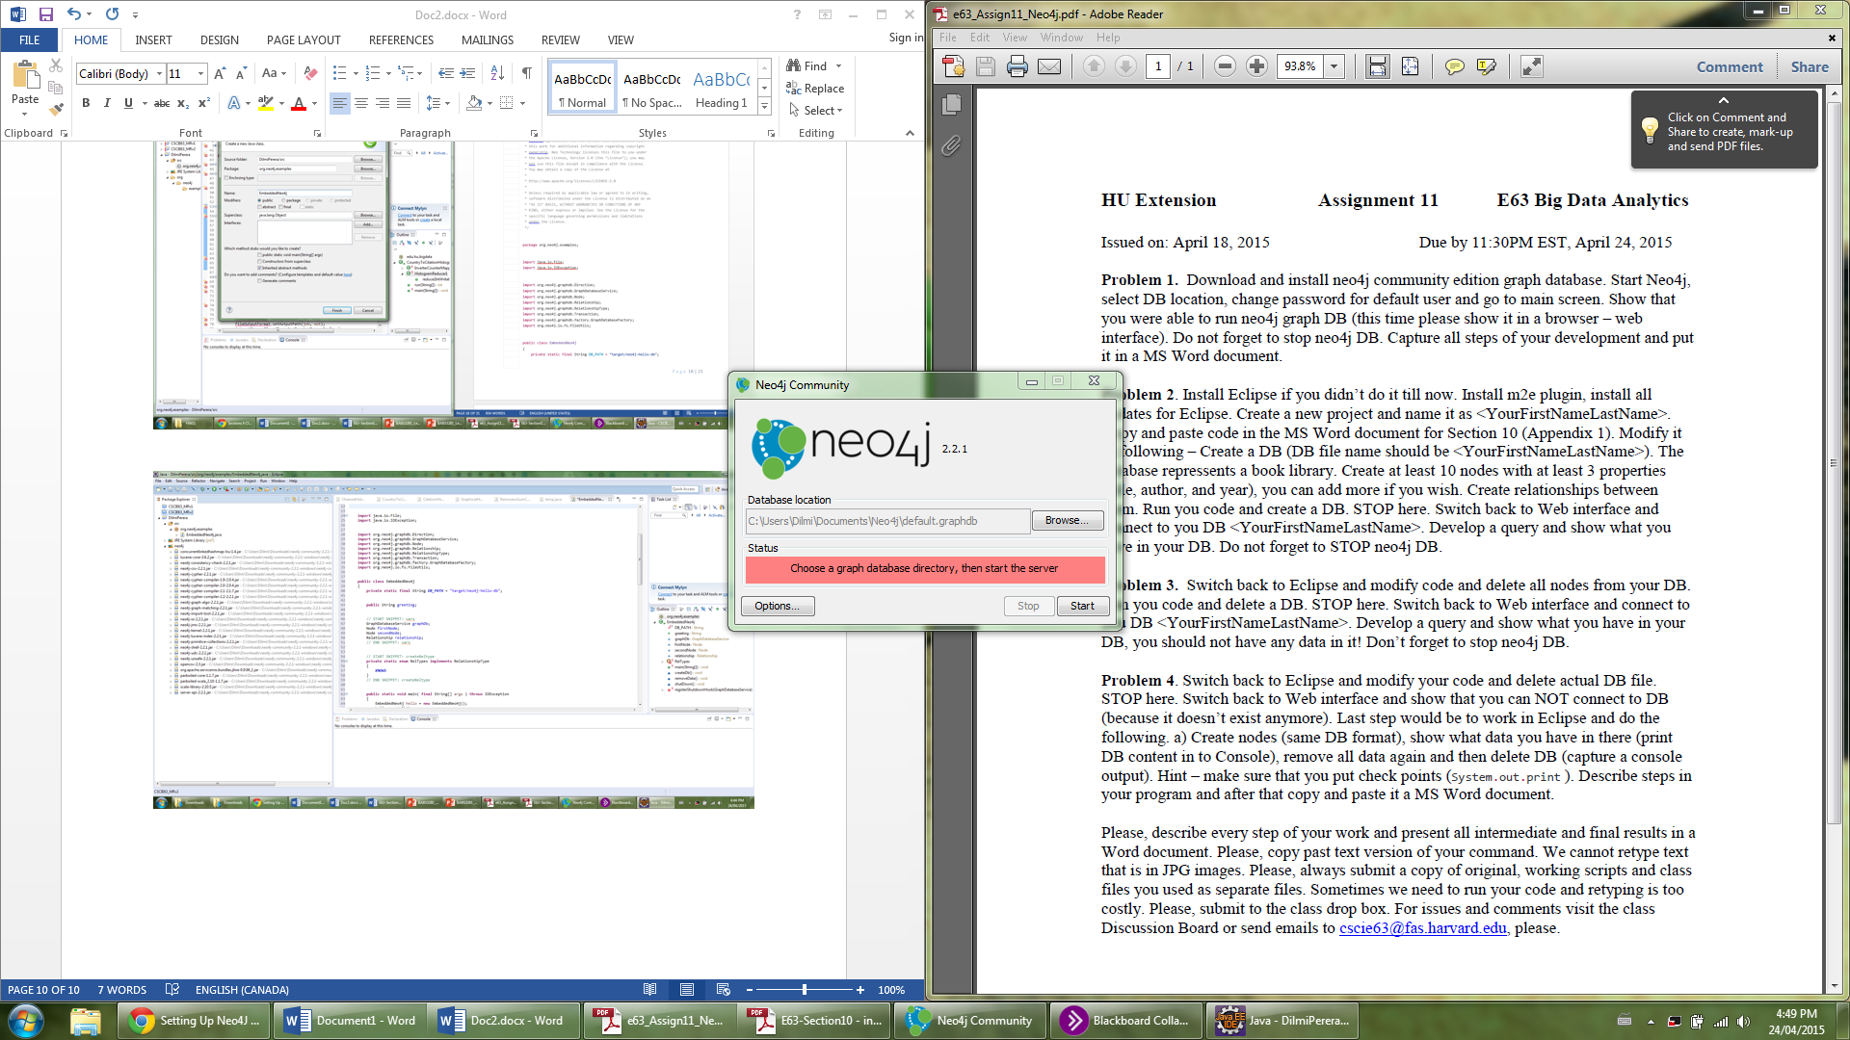

**Select folder with database from eclipse workspace**

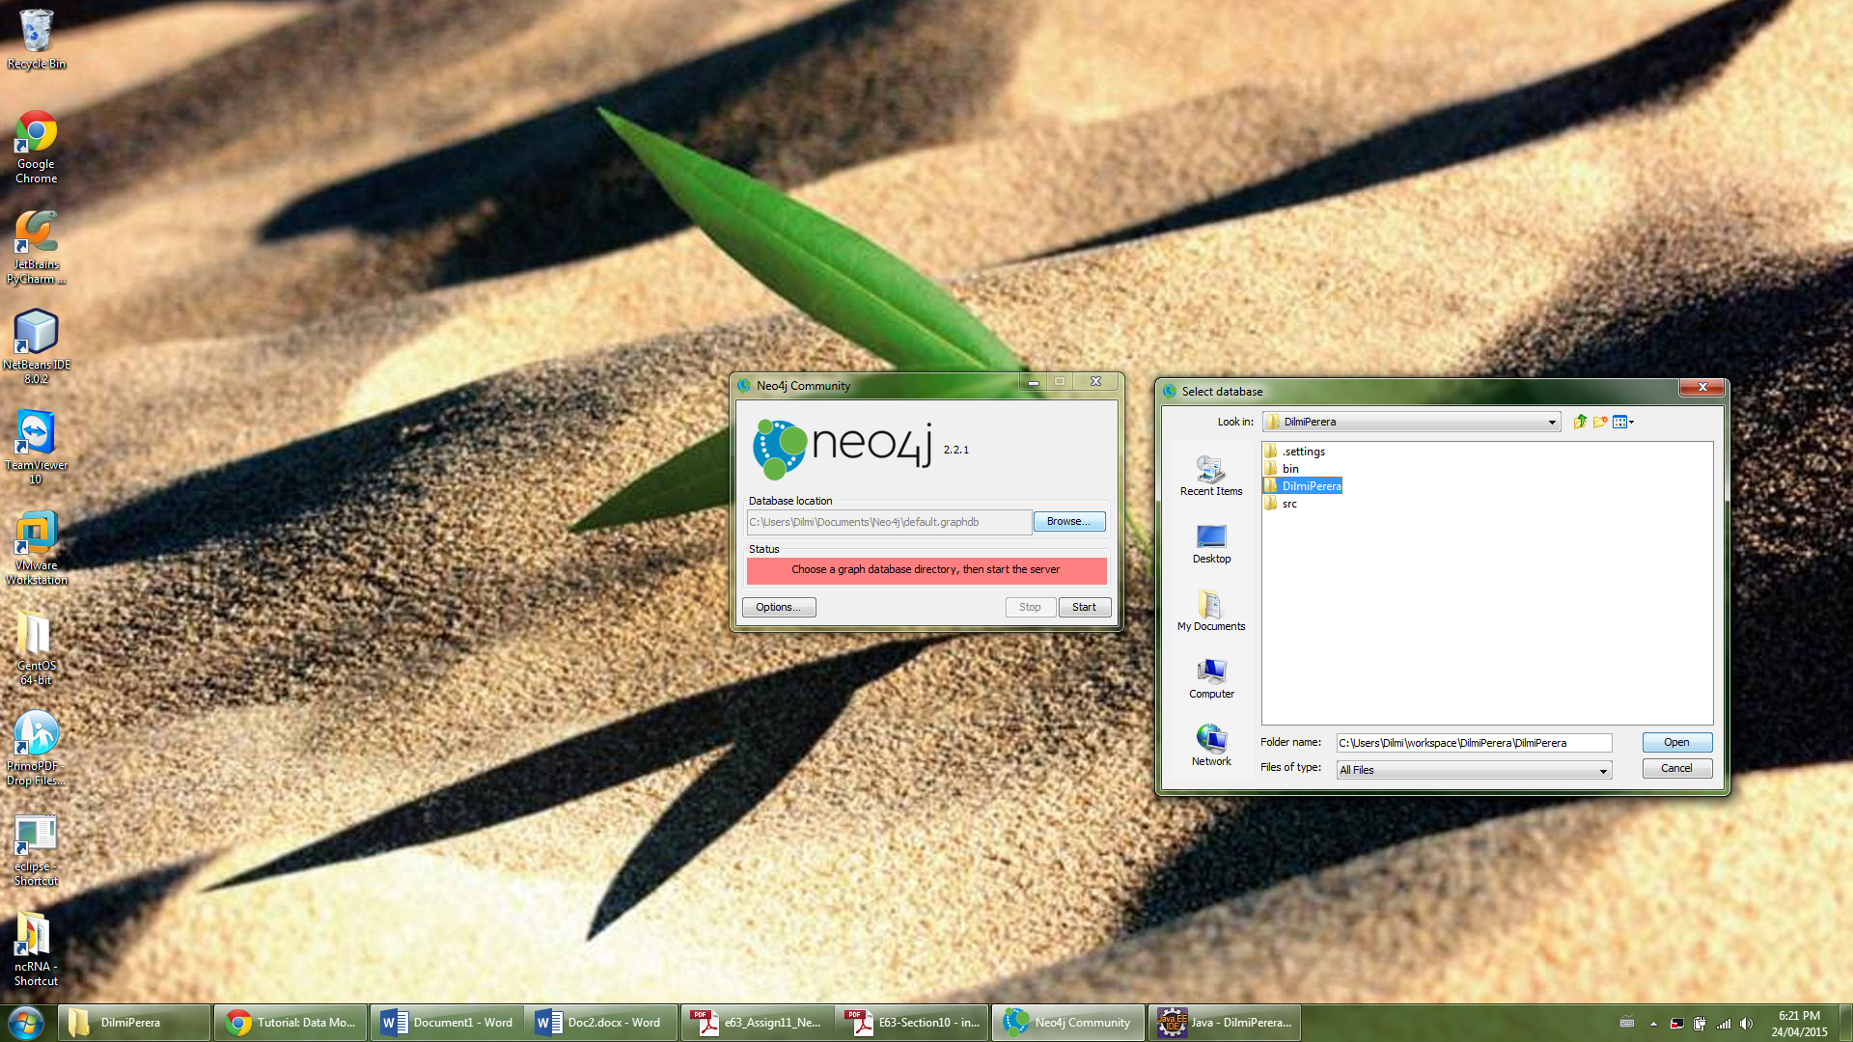

**Start database “DilmiPerera”**

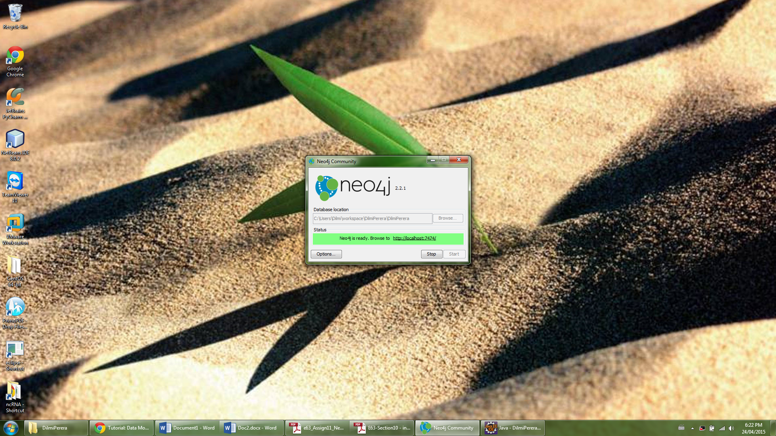

**Go to link, login as default user and change password**

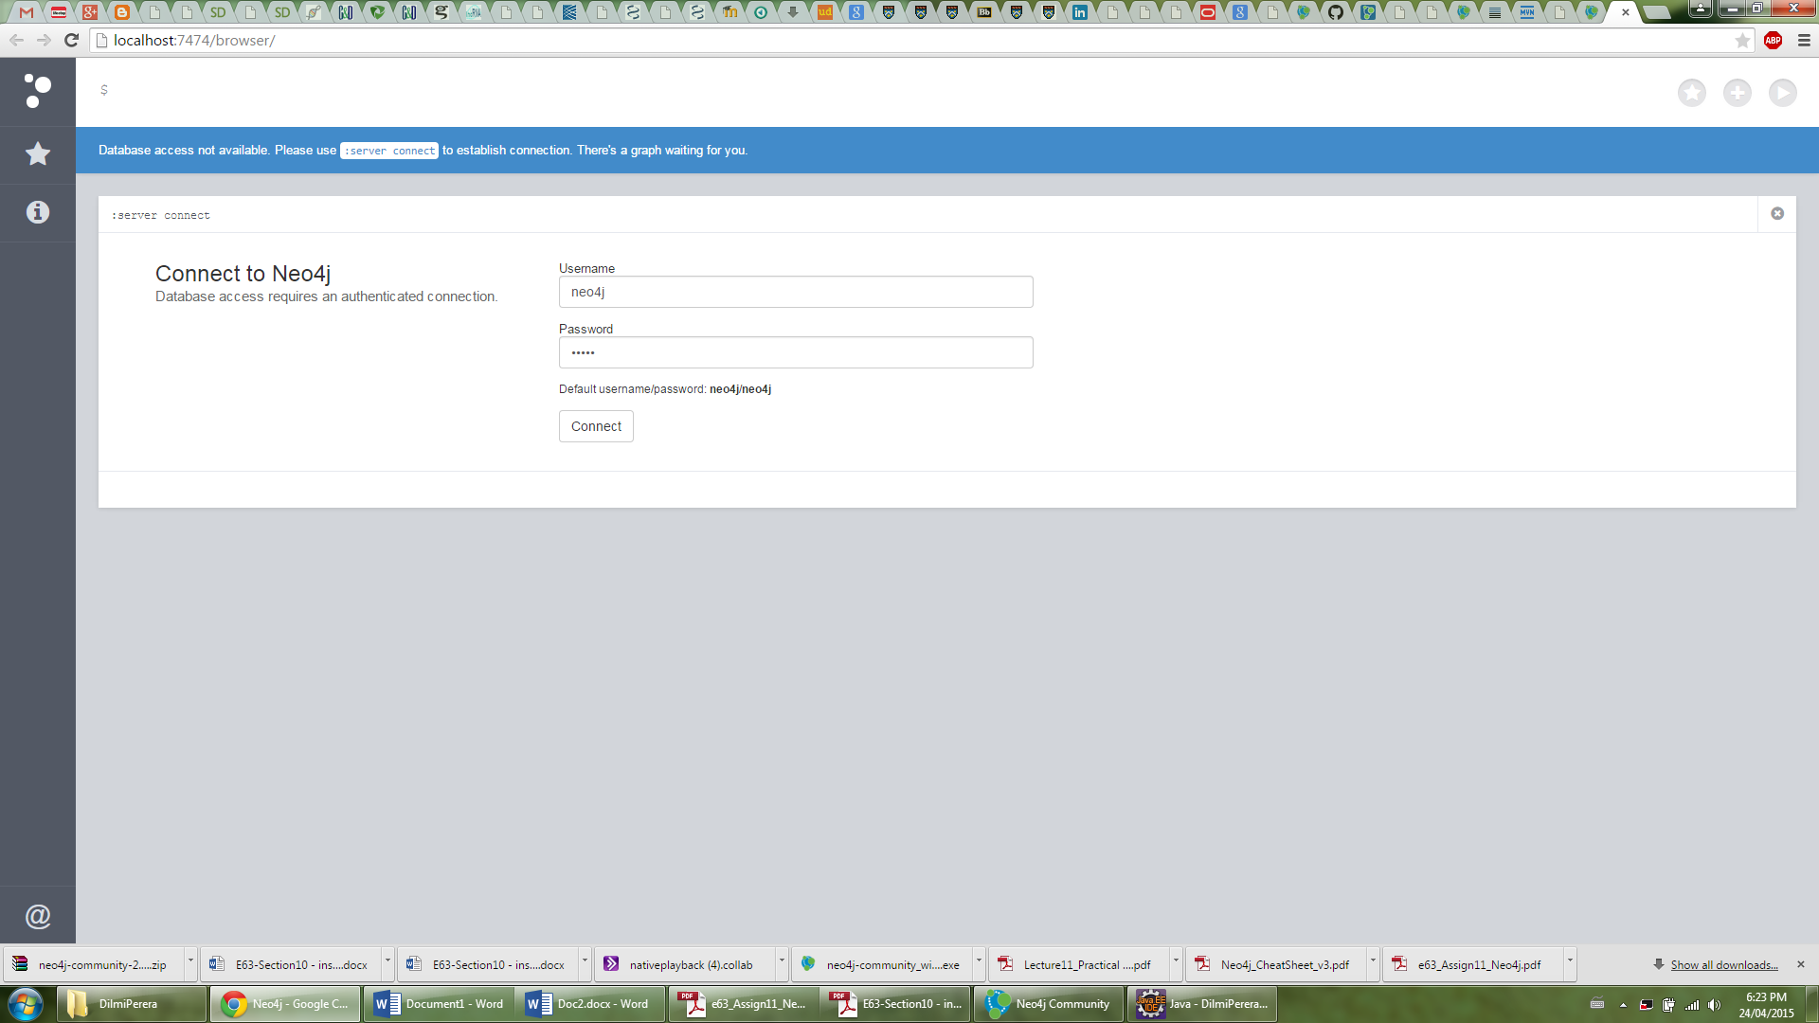

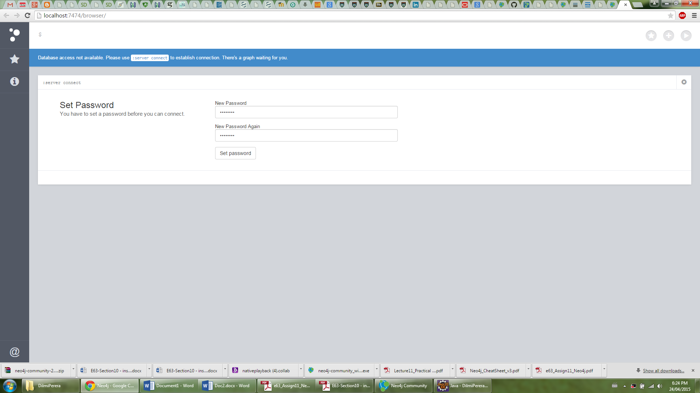

**Retrieve data from database using “Match (n)” and “RETURN n;”**

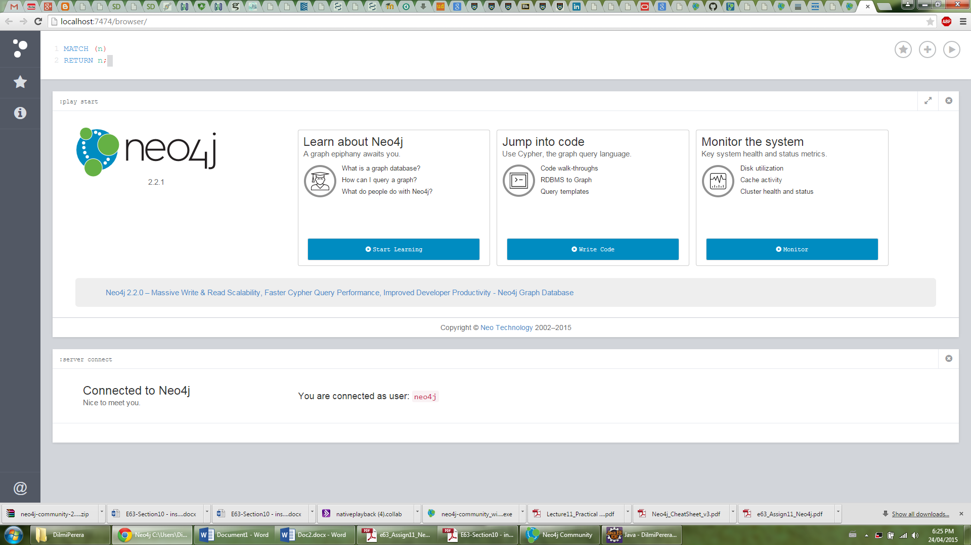

**View output**

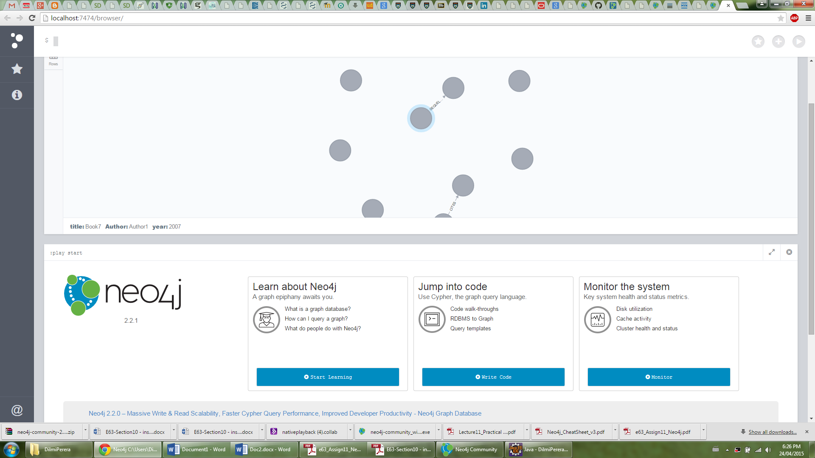

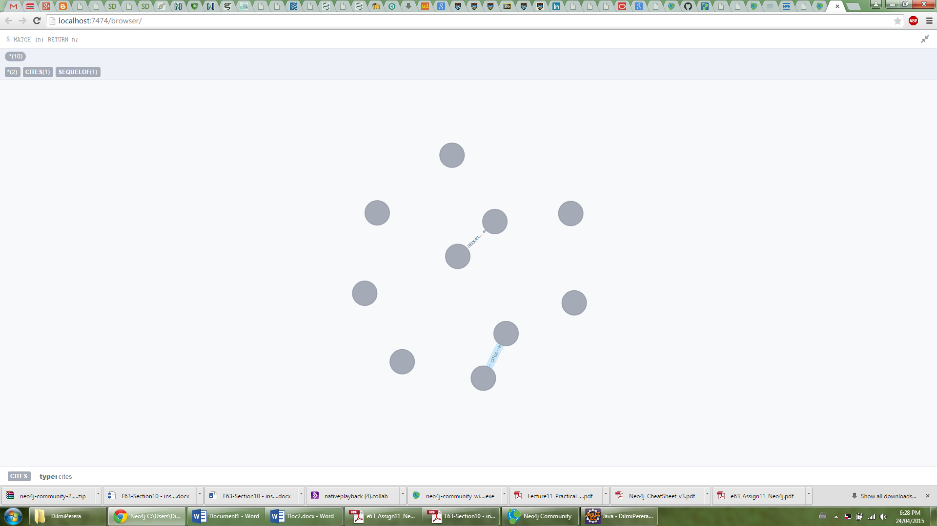

**Stop neo4j**

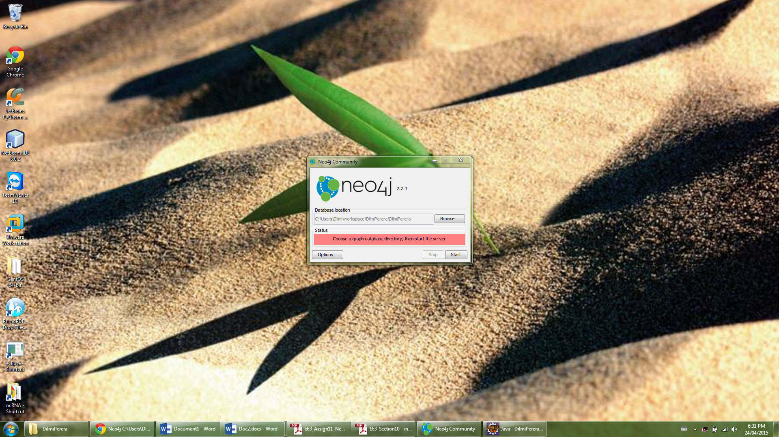

**Problem 3**

**Write code to remove all nodes**

**void** removeData()

{

**try** ( Transaction tx = graphDb.beginTx() )

{

// START SNIPPET: removingData

// let's remove the data

firstNode.getSingleRelationship( RelTypes.***CITES***, Direction.***OUTGOING*** ).delete();

seventhNode.getSingleRelationship( RelTypes2.***SEQUELOF***, Direction.***OUTGOING*** ).delete();

firstNode.delete();

secondNode.delete();

thirdNode.delete();

fourthNode.delete();

fifthNode.delete();

sixthNode.delete();

seventhNode.delete();

eigthNode.delete();

ninthNode.delete();

tenthNode.delete();

// END SNIPPET: removingData

tx.success();

}

}

**Change main method**

**public** **static** **void** main( **final** String[] args ) **throws** IOException

{

EmbeddedNeo4j library = **new** EmbeddedNeo4j();

library.createDb();

library.removeData();

//library.shutDown();

}

**Restart neo4j**

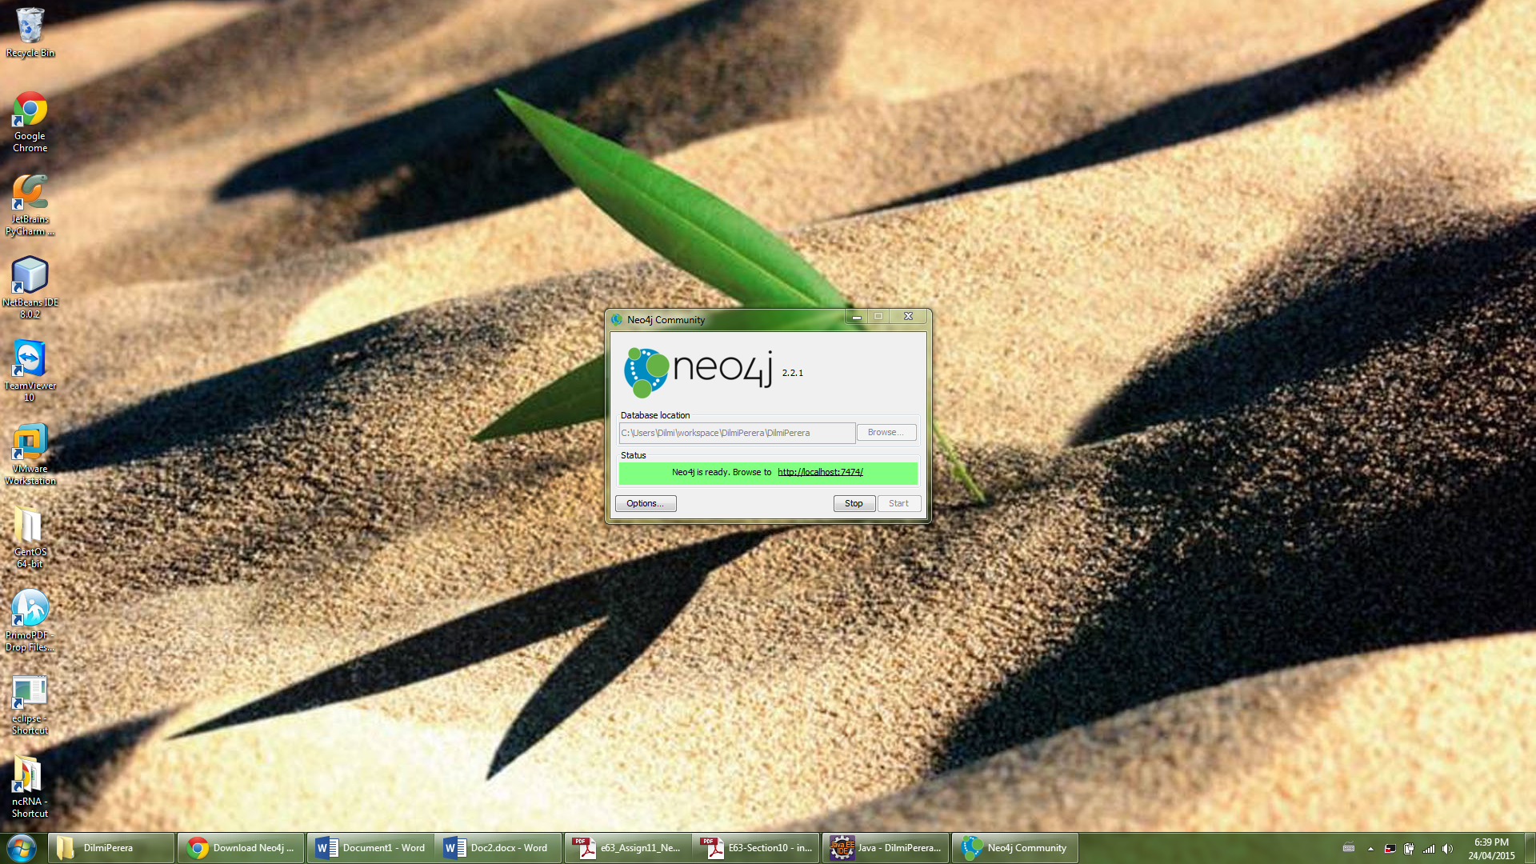

**“No row” returned for query “Match (n)” and “RETURN n;”**

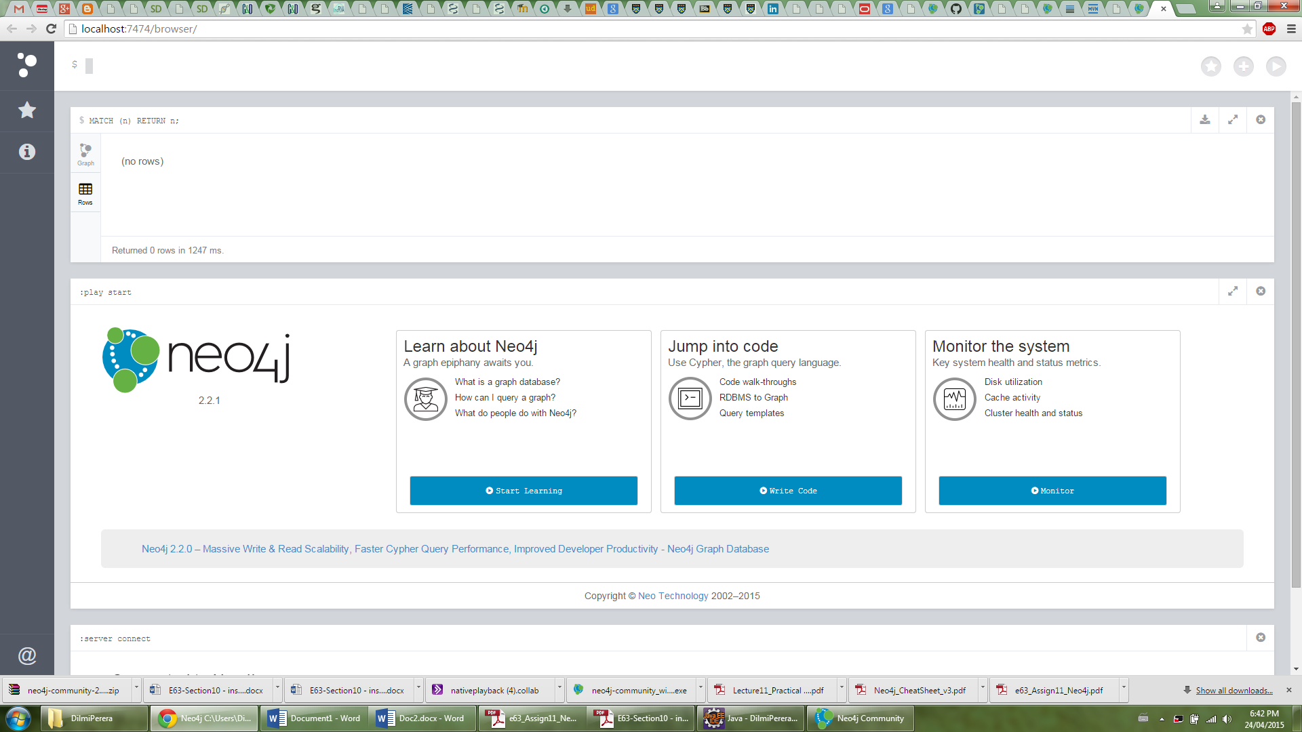

**Stop neo4j**



**Problem 4**

**Modify code to delete files**

**public** **static** **void** main( **final** String[] args ) **throws** IOException

{

FileUtils.*deleteRecursively*( **new** File( ***DB_PATH*** ) );

//EmbeddedNeo4j library = new EmbeddedNeo4j();

//library.createDb();

//library.removeData();

//library.shutDown();

}

**Try connecting to db – database doesn’t exist**

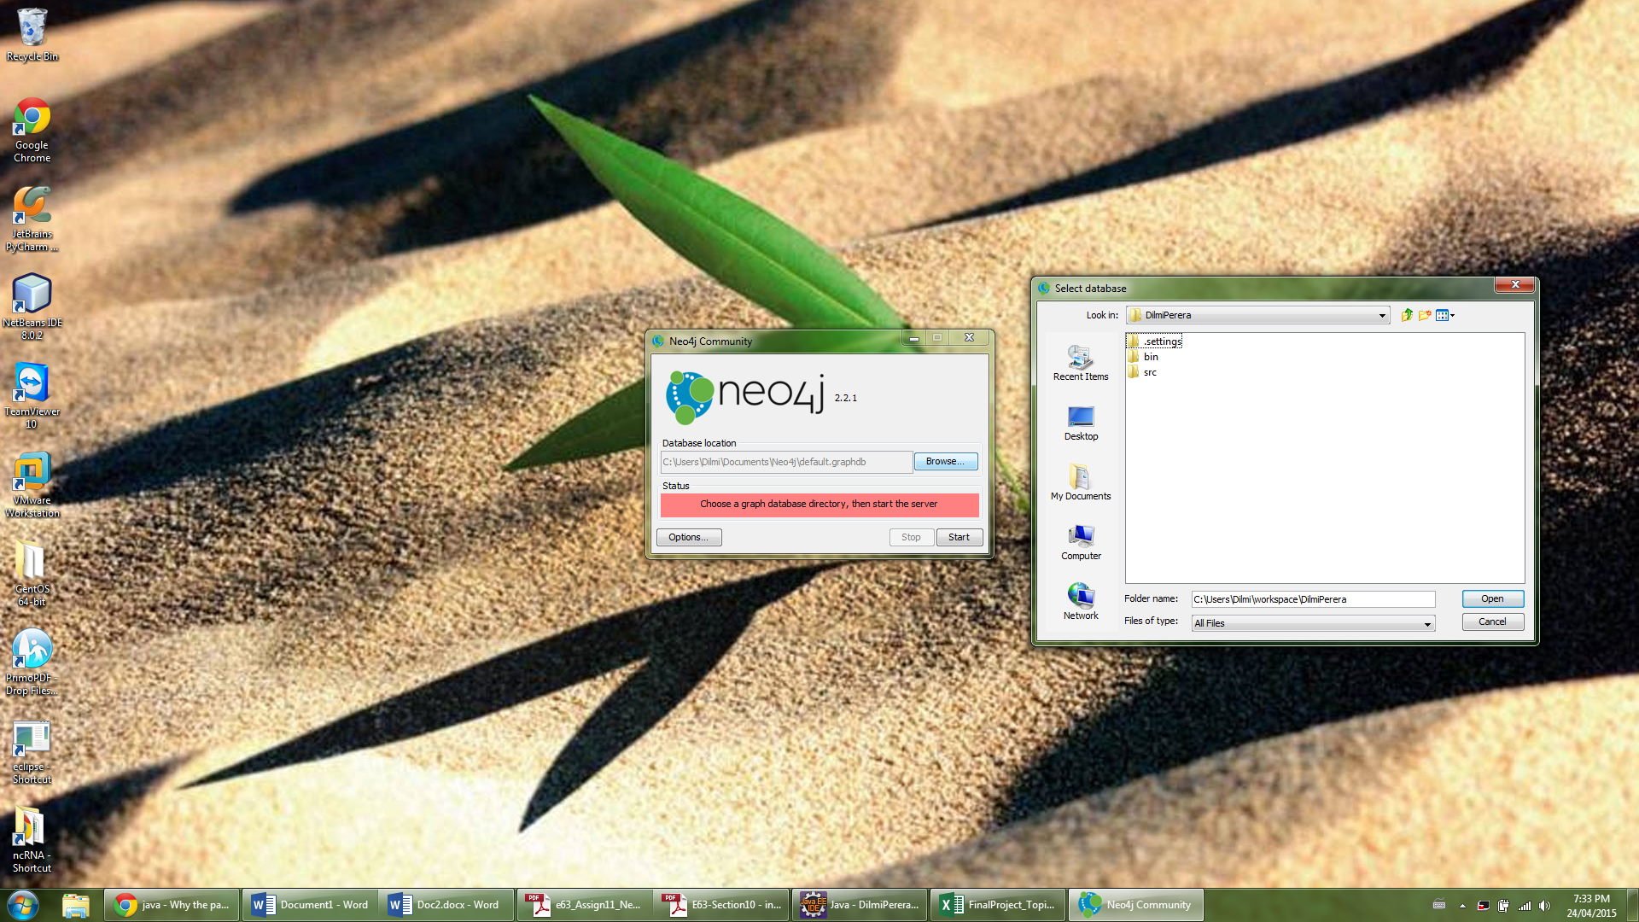

**Console output – Description of the database contents**

String rows="";

Result result = graphDb.execute( "match (n) return n.title, n.Author,n.year;" ) ;

**while** ( result.hasNext() ) {

Map<String,Object> row = result.next();

**for** ( Entry<String,Object> column : row.entrySet() ) {

rows += column.getKey() + ": " + column.getValue() + "; ";

}

rows += "\n";

}

System.***out***.println(rows);

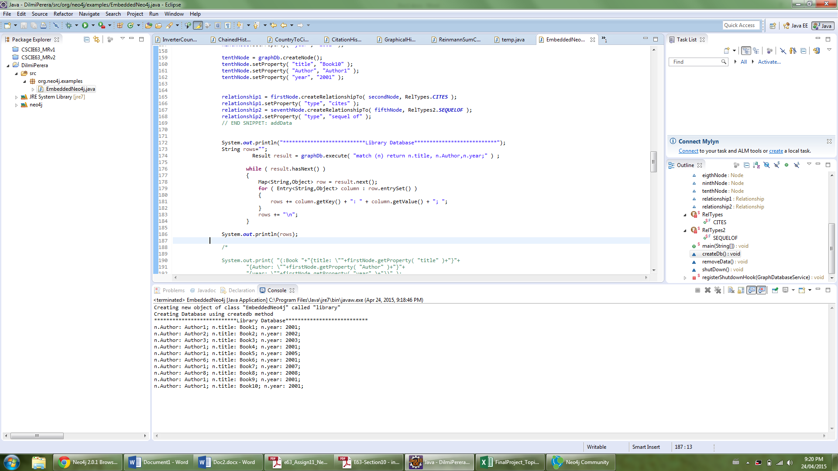

**Remove data and delete db**

**public** **static** **void** main( **final** String[] args ) **throws** IOException

{

System.***out***.println("Creating new object of class \"EmbeddedNeo4j\" called \"library\"");

EmbeddedNeo4j library = **new** EmbeddedNeo4j();

System.***out***.println("Creating Database using createdb method");

library.createDb();

System.***out***.println("Remove data from database");

library.removeData();

library.shutDown();

System.***out***.println("Delete database file");

FileUtils.*deleteRecursively*( **new** File( ***DB_PATH*** ) );

}

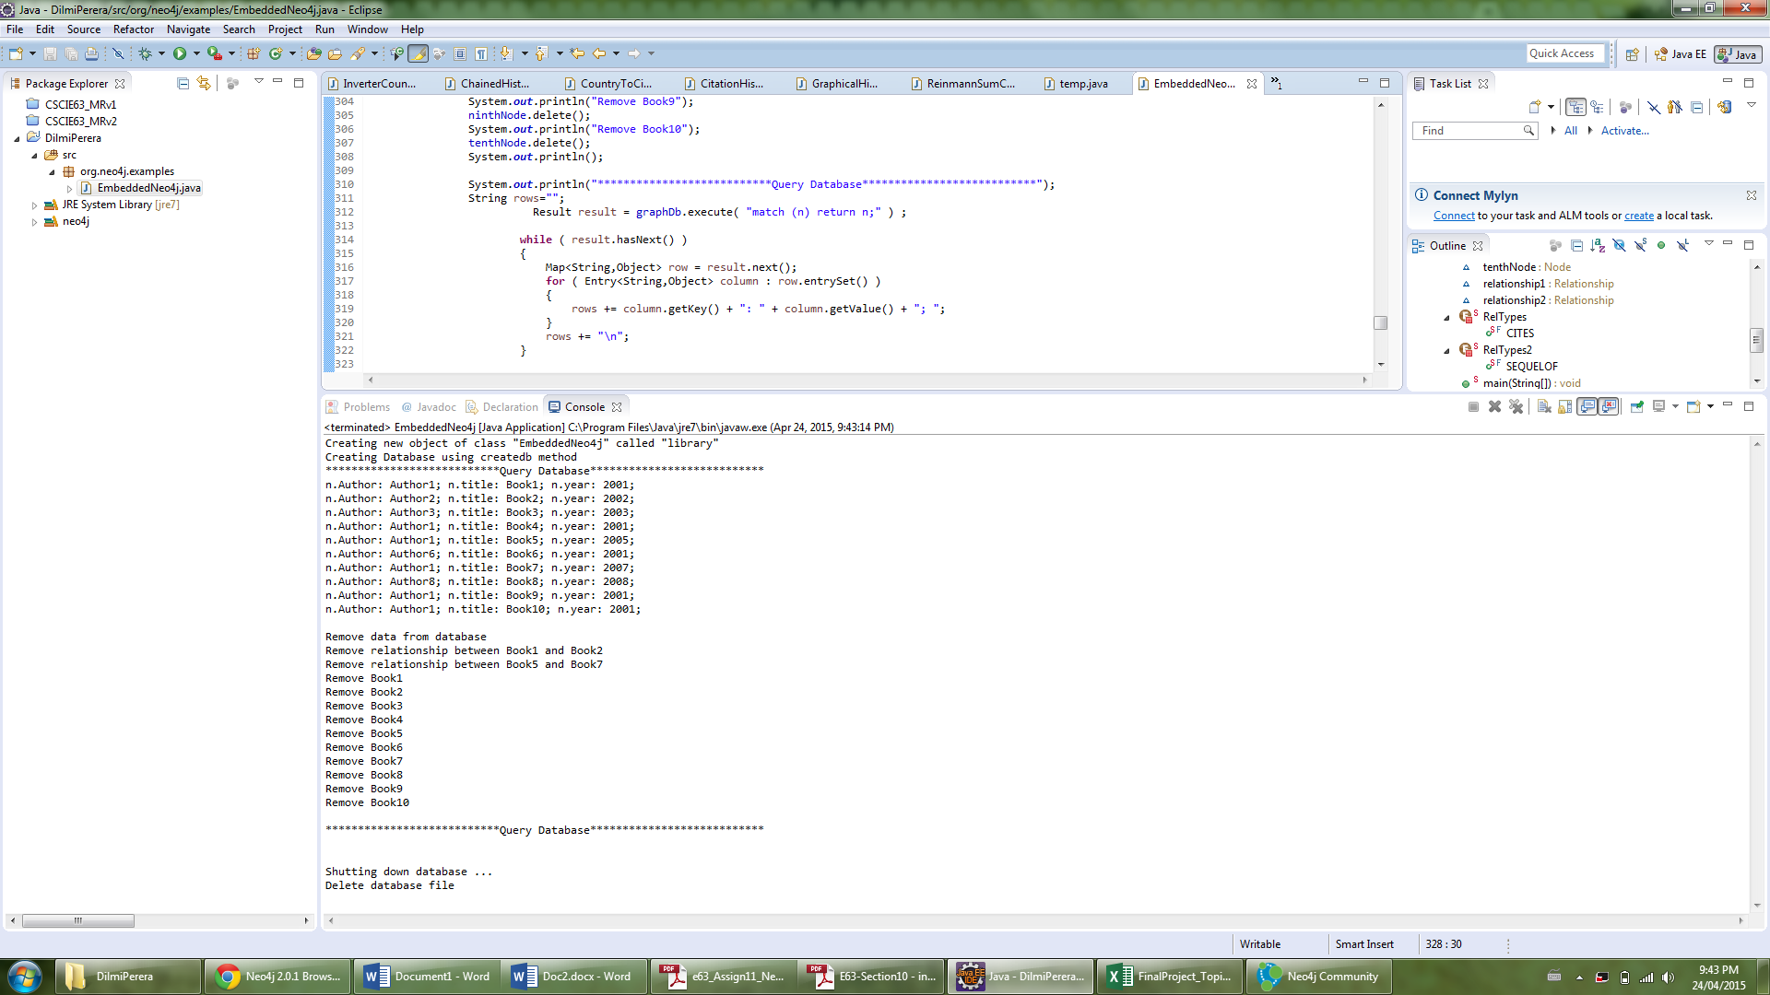

**Console output**

Creating new object of class "EmbeddedNeo4j" called "library"

Creating Database using createdb method

***************************Query Database***************************

n.Author: Author1; n.title: Book1; n.year: 2001;

n.Author: Author2; n.title: Book2; n.year: 2002;

n.Author: Author3; n.title: Book3; n.year: 2003;

n.Author: Author1; n.title: Book4; n.year: 2001;

n.Author: Author1; n.title: Book5; n.year: 2005;

n.Author: Author6; n.title: Book6; n.year: 2001;

n.Author: Author1; n.title: Book7; n.year: 2007;

n.Author: Author8; n.title: Book8; n.year: 2008;

n.Author: Author1; n.title: Book9; n.year: 2001;

n.Author: Author1; n.title: Book10; n.year: 2001;

Remove data from database

Remove relationship between Book1 and Book2

Remove relationship between Book5 and Book7

Remove Book1

Remove Book2

Remove Book3

Remove Book4

Remove Book5

Remove Book6

Remove Book7

Remove Book8

Remove Book9

Remove Book10

***************************Query Database***************************

Shutting down database ...

Delete database file

**Appendix**

**Java source code has been attached**

/**

* Licensed to Neo Technology under one or more contributor

* license agreements. See the NOTICE file distributed with

* this work for additional information regarding copyright

* ownership. Neo Technology licenses this file to you under

* the Apache License, Version 2.0 (the "License"); you may

* not use this file except in compliance with the License.

* You may obtain a copy of the License at

*

* http://www.apache.org/licenses/LICENSE-2.0

*

* Unless required by applicable law or agreed to in writing,

* software distributed under the License is distributed on an

* "AS IS" BASIS, WITHOUT WARRANTIES OR CONDITIONS OF ANY

* KIND, either express or implied. See the License for the

* specific language governing permissions and limitations

* under the License.

*/

**package** org.neo4j.examples;

**import** java.io.File;

**import** java.io.IOException;

**import** java.util.Map;

**import** java.util.Map.Entry;

**import** org.neo4j.graphdb.Direction;

**import** org.neo4j.graphdb.GraphDatabaseService;

**import** org.neo4j.graphdb.Node;

**import** org.neo4j.graphdb.Relationship;

**import** org.neo4j.graphdb.RelationshipType;

**import** org.neo4j.graphdb.Result;

**import** org.neo4j.graphdb.Transaction;

**import** org.neo4j.graphdb.factory.GraphDatabaseFactory;

**import** org.neo4j.io.fs.FileUtils;

**public** **class** EmbeddedNeo4j

{

**private** **static** **final** String ***DB_PATH*** = "DilmiPerera";

**public** String greeting;

// START SNIPPET: vars

GraphDatabaseService graphDb;

Node firstNode;

Node secondNode;

Node thirdNode;

Node fourthNode;

Node fifthNode;

Node sixthNode;

Node seventhNode;

Node eigthNode;

Node ninthNode;

Node tenthNode;

Relationship relationship1;

Relationship relationship2;

// END SNIPPET: vars

// START SNIPPET: createReltype

**private** **static** **enum** RelTypes **implements** RelationshipType

{

***CITES***

}

// END SNIPPET: createReltype

// START SNIPPET: createReltype

**private** **static** **enum** RelTypes2 **implements** RelationshipType

{

***SEQUELOF***

}

// END SNIPPET: createReltype

**public** **static** **void** main( **final** String[] args ) **throws** IOException

{

System.***out***.println("Creating new object of class \"EmbeddedNeo4j\" called \"library\"");

EmbeddedNeo4j library = **new** EmbeddedNeo4j();

System.***out***.println("Creating Database using createdb method");

library.createDb();

System.***out***.println("Remove data from database");

library.removeData();

library.shutDown();

System.***out***.println("Delete database file");

FileUtils.*deleteRecursively*( **new** File( ***DB_PATH*** ) );

}

**void** createDb() **throws** IOException

{

FileUtils.*deleteRecursively*( **new** File( ***DB_PATH*** ) );

// START SNIPPET: startDb

graphDb = **new** GraphDatabaseFactory().newEmbeddedDatabase( ***DB_PATH*** );

*registerShutdownHook*( graphDb );

// END SNIPPET: startDb

// START SNIPPET: transaction

**try** ( Transaction tx = graphDb.beginTx() )

{

// Database operations go here

// END SNIPPET: transaction

// START SNIPPET: addData

firstNode = graphDb.createNode();

firstNode.setProperty( "title", "Book1" );

firstNode.setProperty( "Author", "Author1" );

firstNode.setProperty( "year", "2001" );

secondNode = graphDb.createNode();

secondNode.setProperty( "title", "Book2" );

secondNode.setProperty( "Author", "Author2" );

secondNode.setProperty( "year", "2002" );

thirdNode = graphDb.createNode();

thirdNode.setProperty( "title", "Book3" );

thirdNode.setProperty( "Author", "Author3" );

thirdNode.setProperty( "year", "2003" );

fourthNode = graphDb.createNode();

fourthNode.setProperty( "title", "Book4" );

fourthNode.setProperty( "Author", "Author1" );

fourthNode.setProperty( "year", "2001" );

fifthNode = graphDb.createNode();

fifthNode.setProperty( "title", "Book5" );

fifthNode.setProperty( "Author", "Author1" );

fifthNode.setProperty( "year", "2005" );

sixthNode = graphDb.createNode();

sixthNode.setProperty( "title", "Book6" );

sixthNode.setProperty( "Author", "Author6" );

sixthNode.setProperty( "year", "2001" );

seventhNode = graphDb.createNode();

seventhNode.setProperty( "title", "Book7" );

seventhNode.setProperty( "Author", "Author1");

seventhNode.setProperty("year", "2007") ;

eigthNode = graphDb.createNode();

eigthNode.setProperty( "title", "Book8" );

eigthNode.setProperty( "Author", "Author8" );

eigthNode.setProperty( "year", "2008" );

ninthNode = graphDb.createNode();

ninthNode.setProperty( "title", "Book9" );

ninthNode.setProperty( "Author", "Author1" );

ninthNode.setProperty( "year", "2001" );

tenthNode = graphDb.createNode();

tenthNode.setProperty( "title", "Book10" );

tenthNode.setProperty( "Author", "Author1" );

tenthNode.setProperty( "year", "2001" );

relationship1 = firstNode.createRelationshipTo( secondNode, RelTypes.***CITES*** );

relationship1.setProperty( "type", "cites" );

relationship2 = seventhNode.createRelationshipTo( fifthNode, RelTypes2.***SEQUELOF*** );

relationship2.setProperty( "type", "sequel of" );

// END SNIPPET: addData

System.***out***.println("***************************Query Database***************************");

String rows="";

Result result = graphDb.execute( "match (n) return n.title, n.Author,n.year;" ) ;

**while** ( result.hasNext() )

{

Map<String,Object> row = result.next();

**for** ( Entry<String,Object> column : row.entrySet() )

{

rows += column.getKey() + ": " + column.getValue() + "; ";

}

rows += "\n";

}

System.***out***.println(rows)

/*

// START SNIPPET: readData

System.out.print( firstNode.getProperty( "title" )+"\t" );

System.out.print( relationship1.getProperty( "type" ) +"\t");

System.out.println( secondNode.getProperty( "title" ) );

// END SNIPPET: readData

greeting = ( (String) firstNode.getProperty("title" ) )

+ ( (String) relationship1.getProperty( "type" ) )

+ ( (String) secondNode.getProperty( "title" ) );

// START SNIPPET: readData

System.out.print( seventhNode.getProperty( "title" ) +"\t");

System.out.print( relationship2.getProperty( "type" ) +"\t");

System.out.print( fifthNode.getProperty( "title" ) );

// END SNIPPET: readData

greeting = ( (String) seventhNode.getProperty("title" ) )

+ ( (String) relationship2.getProperty( "type" ) )

+ ( (String) fifthNode.getProperty( "title" ) );

*/

// START SNIPPET: transaction

tx.success();

}

// END SNIPPET: transaction

}

**void** removeData()

{

**try** ( Transaction tx = graphDb.beginTx() )

{

// START SNIPPET: removingData

// let's remove the data

System.***out***.println("Remove relationship between Book1 and Book2");

firstNode.getSingleRelationship( RelTypes.***CITES***, Direction.***OUTGOING*** ).delete();

System.***out***.println("Remove relationship between Book5 and Book7");

seventhNode.getSingleRelationship( RelTypes2.***SEQUELOF***, Direction.***OUTGOING*** ).delete();

System.***out***.println("Remove Book1");

firstNode.delete();

System.***out***.println("Remove Book2");

secondNode.delete();

System.***out***.println("Remove Book3");

thirdNode.delete();

System.***out***.println("Remove Book4");

fourthNode.delete();

System.***out***.println("Remove Book5");

fifthNode.delete();

System.***out***.println("Remove Book6");

sixthNode.delete();

System.***out***.println("Remove Book7");

seventhNode.delete();

System.***out***.println("Remove Book8");

eigthNode.delete();

System.***out***.println("Remove Book9");

ninthNode.delete();

System.***out***.println("Remove Book10");

tenthNode.delete();

System.***out***.println();

System.***out***.println("***************************Query Database***************************");

String rows="";

Result result = graphDb.execute( "match (n) return n;" ) ;

**while** ( result.hasNext() )

{

Map<String,Object> row = result.next();

**for** ( Entry<String,Object> column : row.entrySet() )

{

rows += column.getKey() + ": " + column.getValue() + "; ";

}

rows += "\n";

}

System.***out***.println(rows);

// END SNIPPET: removingData

tx.success();

}

}

**void** shutDown()

{

System.***out***.println();

System.***out***.println( "Shutting down database ..." );

// START SNIPPET: shutdownServer

graphDb.shutdown();

// END SNIPPET: shutdownServer

}

// START SNIPPET: shutdownHook

**private** **static** **void** registerShutdownHook( **final** GraphDatabaseService graphDb )

{

// Registers a shutdown hook for the Neo4j instance so that it

// shuts down nicely when the VM exits (even if you "Ctrl-C" the

// running application).

Runtime.*getRuntime*().addShutdownHook( **new** Thread()

{

@Override

**public** **void** run()

{

graphDb.shutdown();

}

} );

}

// END SNIPPET: shutdownHook

}